<https://explore.skillbuilder.aws/learn/course/134/play/31418/aws-cloud-practitioner-essentials-all-modules>

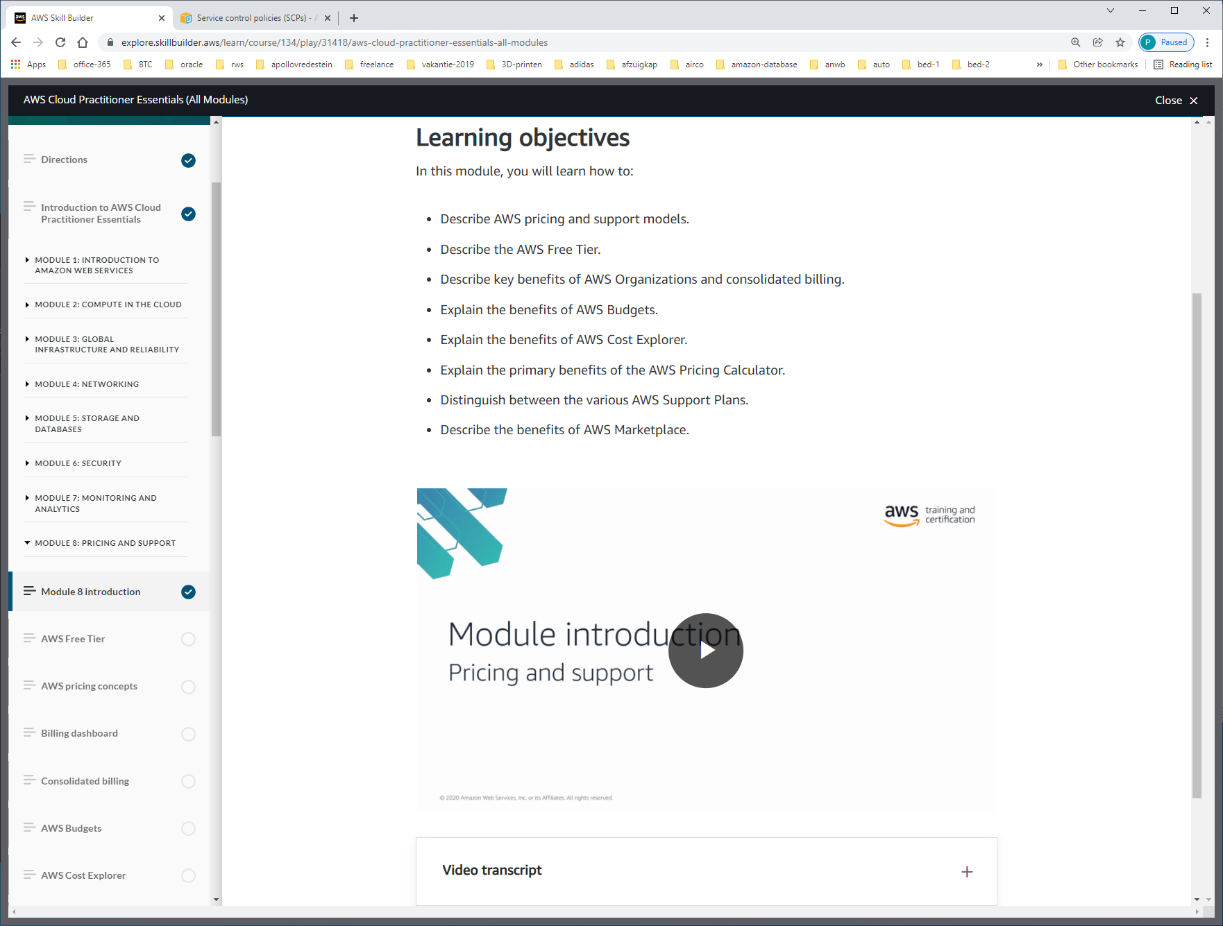a

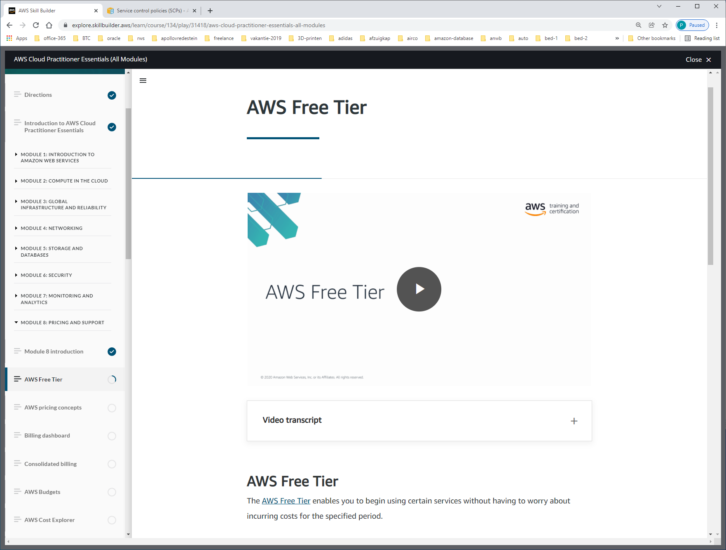

The [AWS Free Tier](https://aws.amazon.com/free/) enables you to begin using certain services without having to worry about incurring costs for the specified period.  Three types of offers are available:

* Always Free These offers do not expire and are available to all AWS customers.
* 12 Months Free These offers are free for 12 months following your initial sign-up date to AWS
* Trials Short-term free trial offers start from the date you activate a particular service. The length of each trial might vary by number of days or the amount of usage in the service.

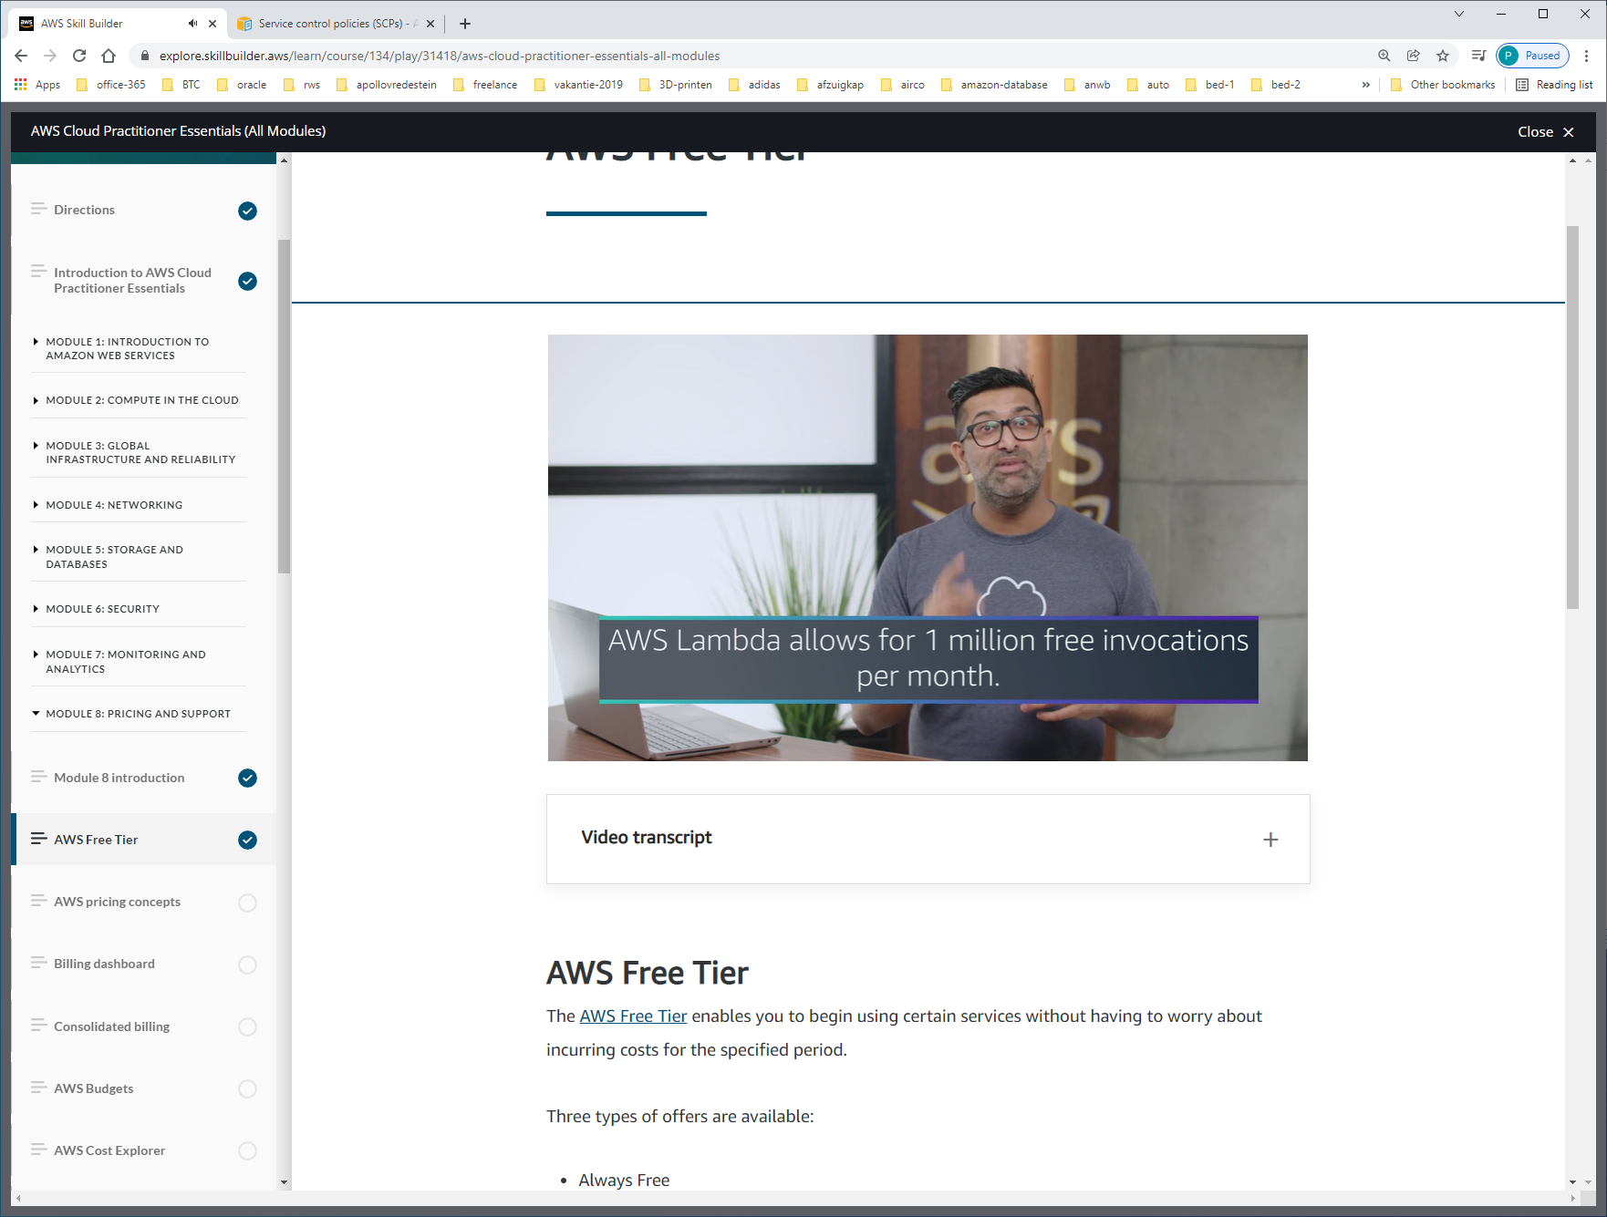

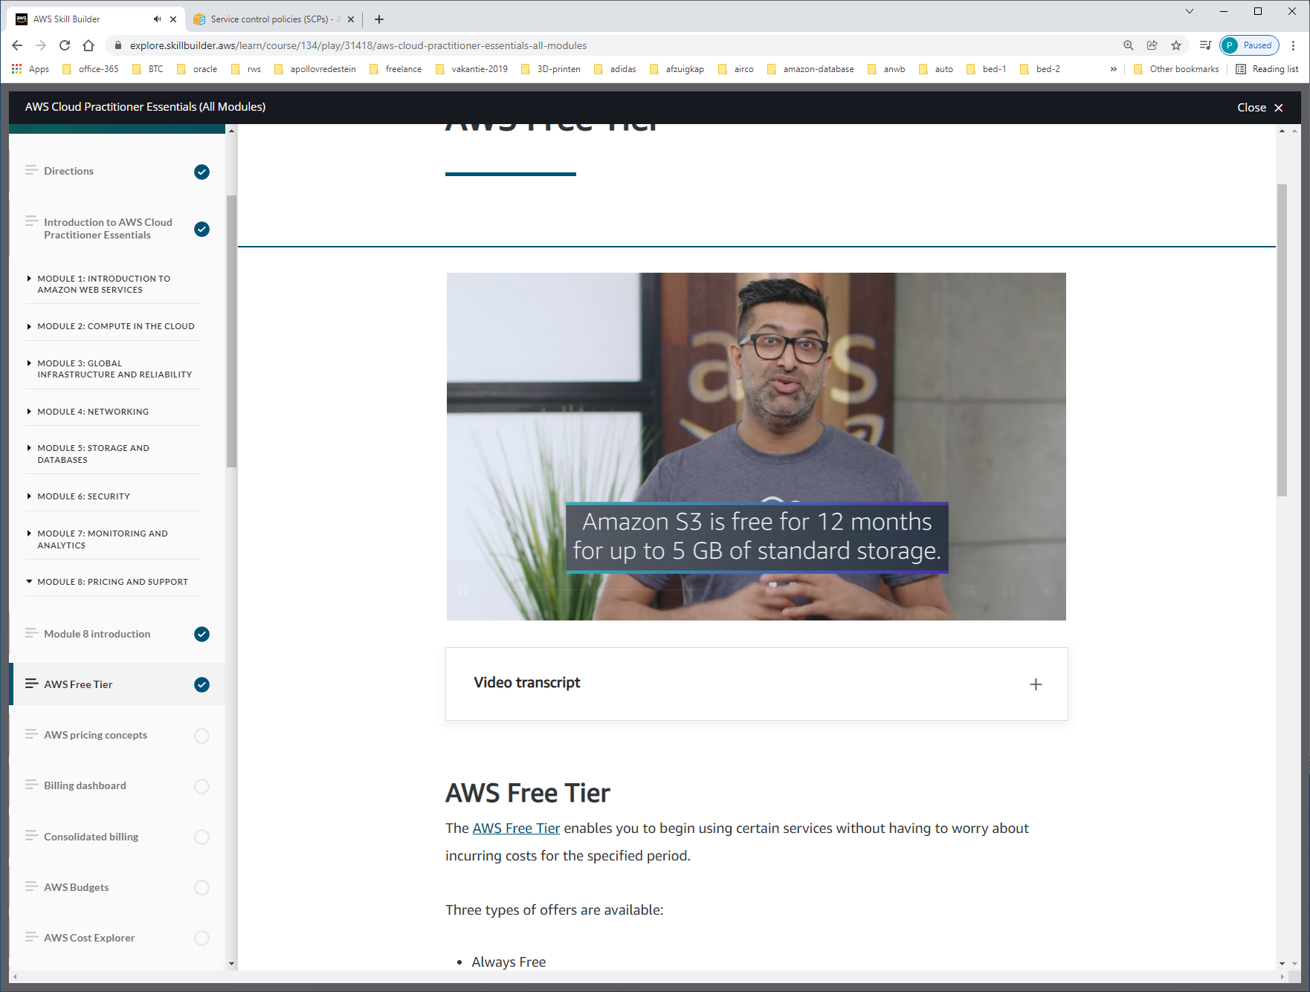

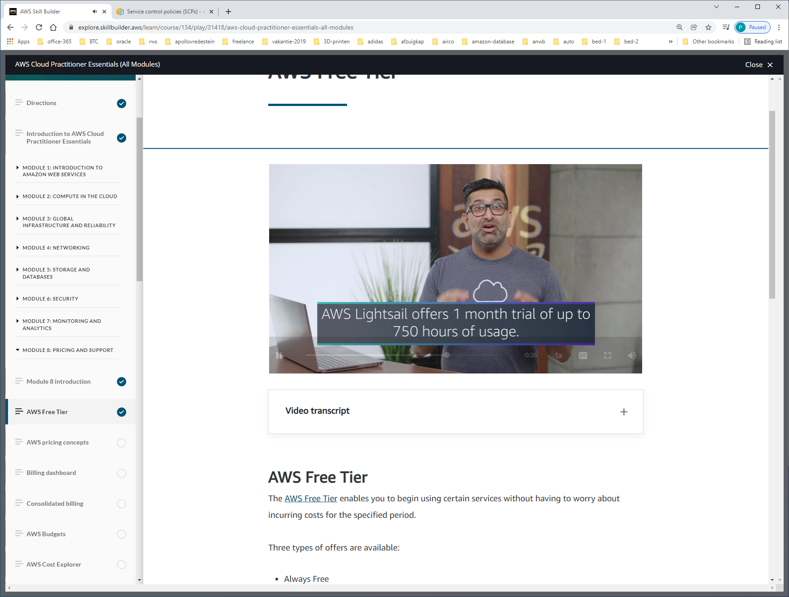

Lightsail = tool voor deployen van applicaties.

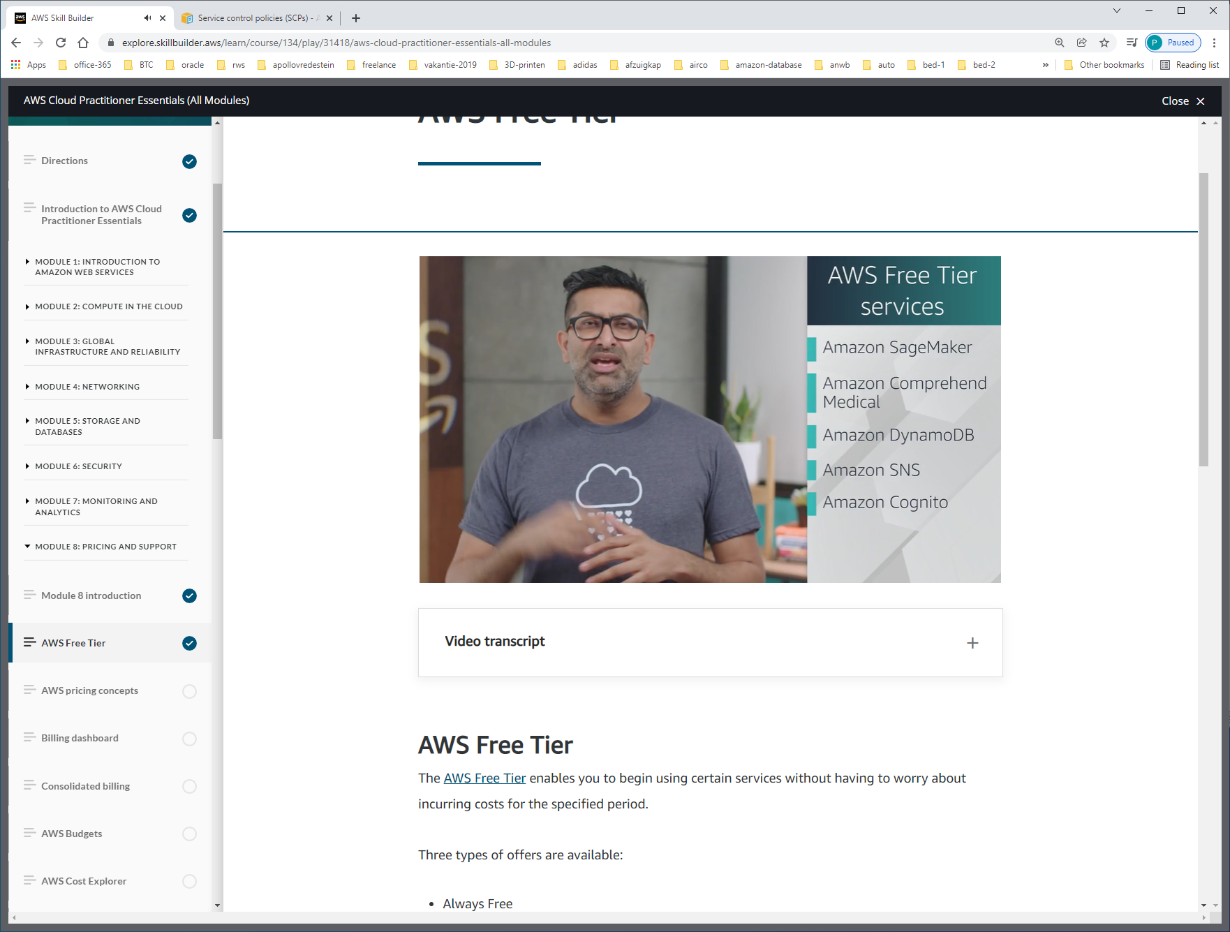

Er zijn ongeveer 60 free-services.

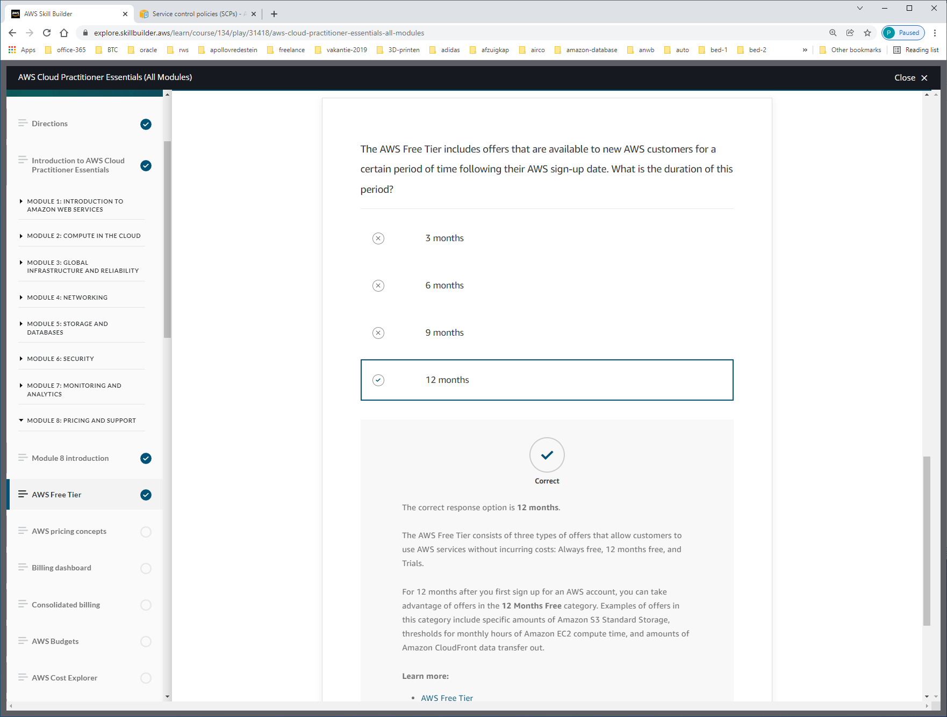

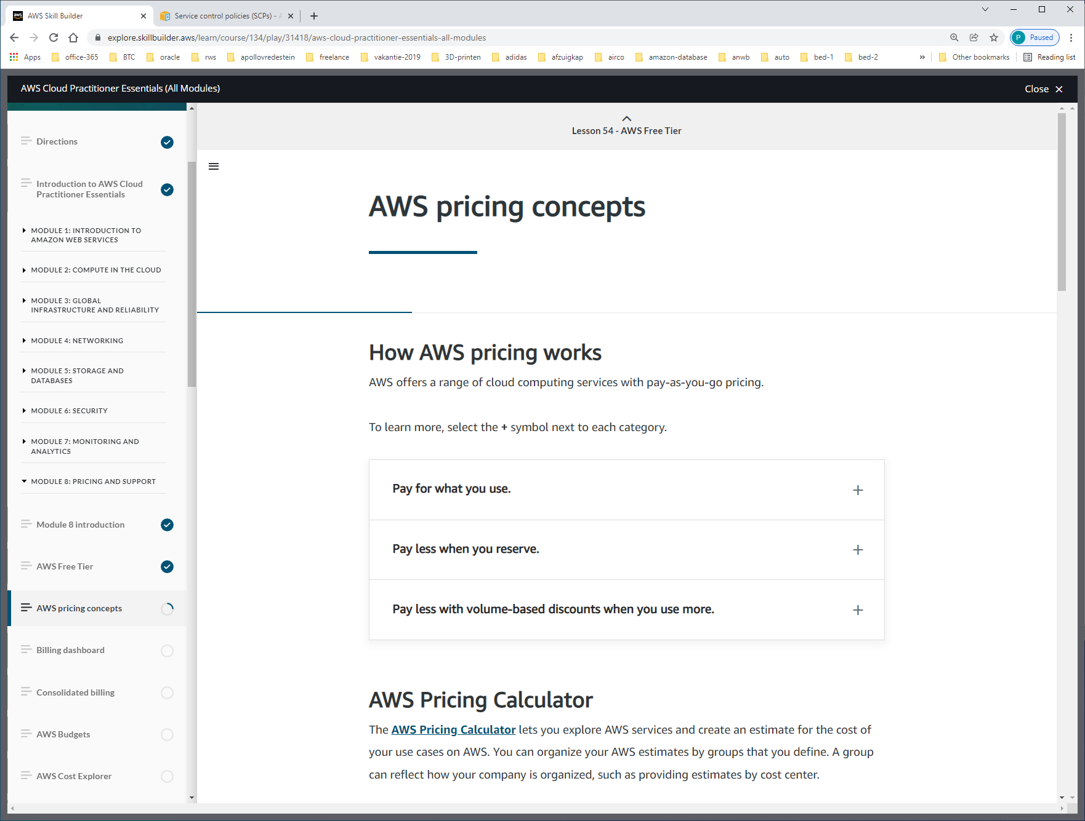

AWS offers a range of cloud computing services with pay-as-you-go pricing.

**Pay for what you use.**

For each service, you pay for exactly the amount of resources that you actually use, without requiring long-term contracts or complex licensing.

**Pay less when you reserve.**

Some services offer reservation options that provide a significant discount compared to On-Demand Instance pricing.

For example, suppose that your company is using Amazon EC2 instances for a workload that needs to run continuously. You might choose to run this workload on Amazon EC2 Instance Savings Plans, because the plan allows you to save up to 72% over the equivalent On-Demand Instance capacity.

**Pay less with volume-based discounts when you use more.**

Some services offer tiered pricing, so the per-unit cost is incrementally lower with increased usage.

For example, the more Amazon S3 storage space you use, the less you pay for it per GB.

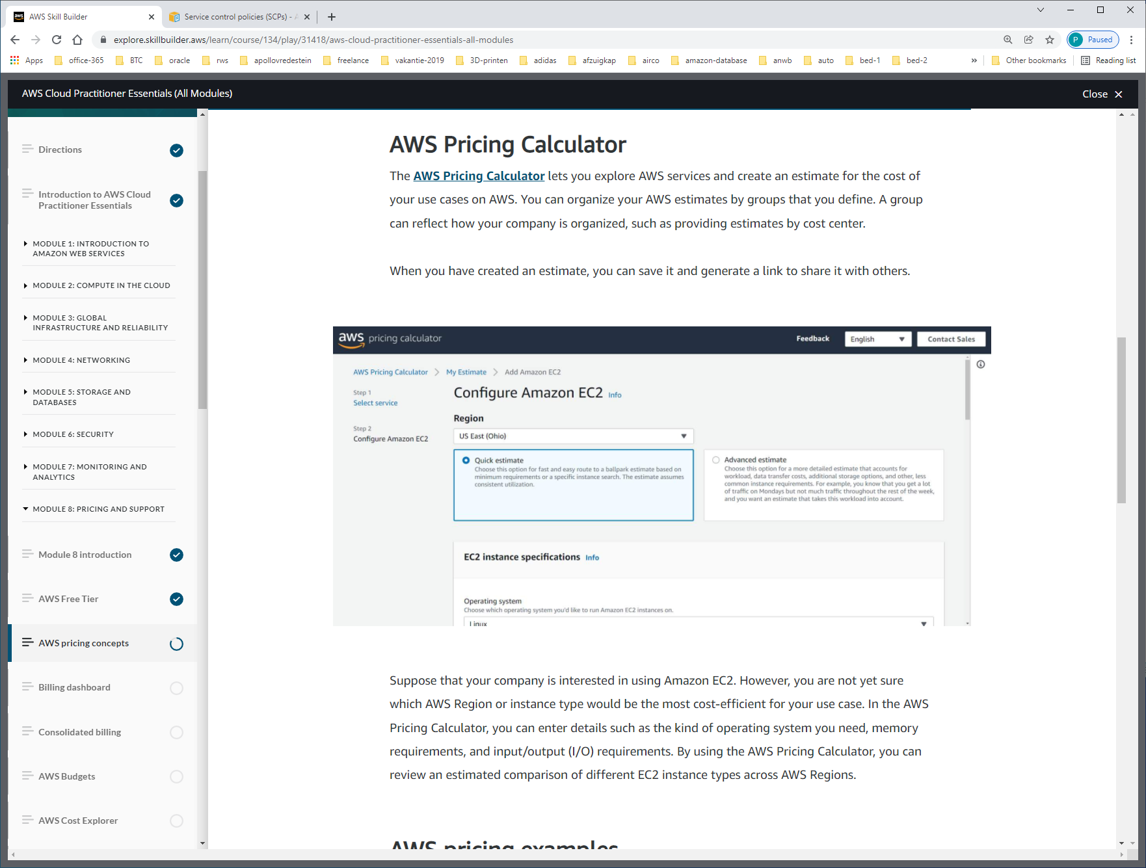

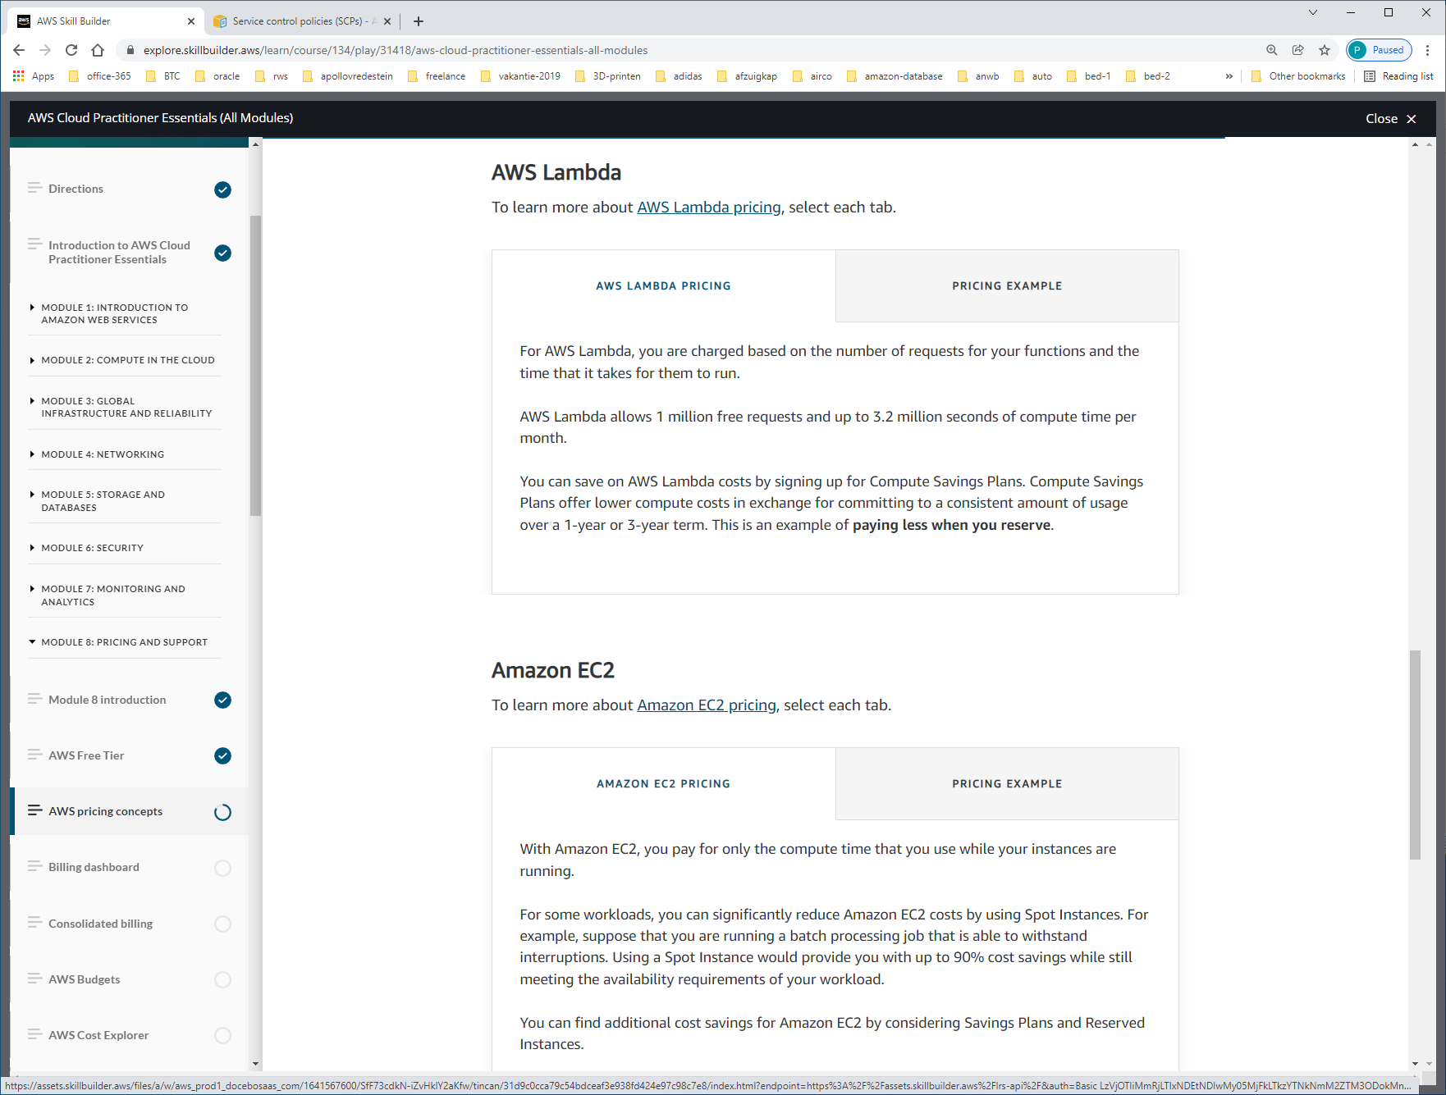

Uitzoeken: saving-plans (storage/compute etc)?

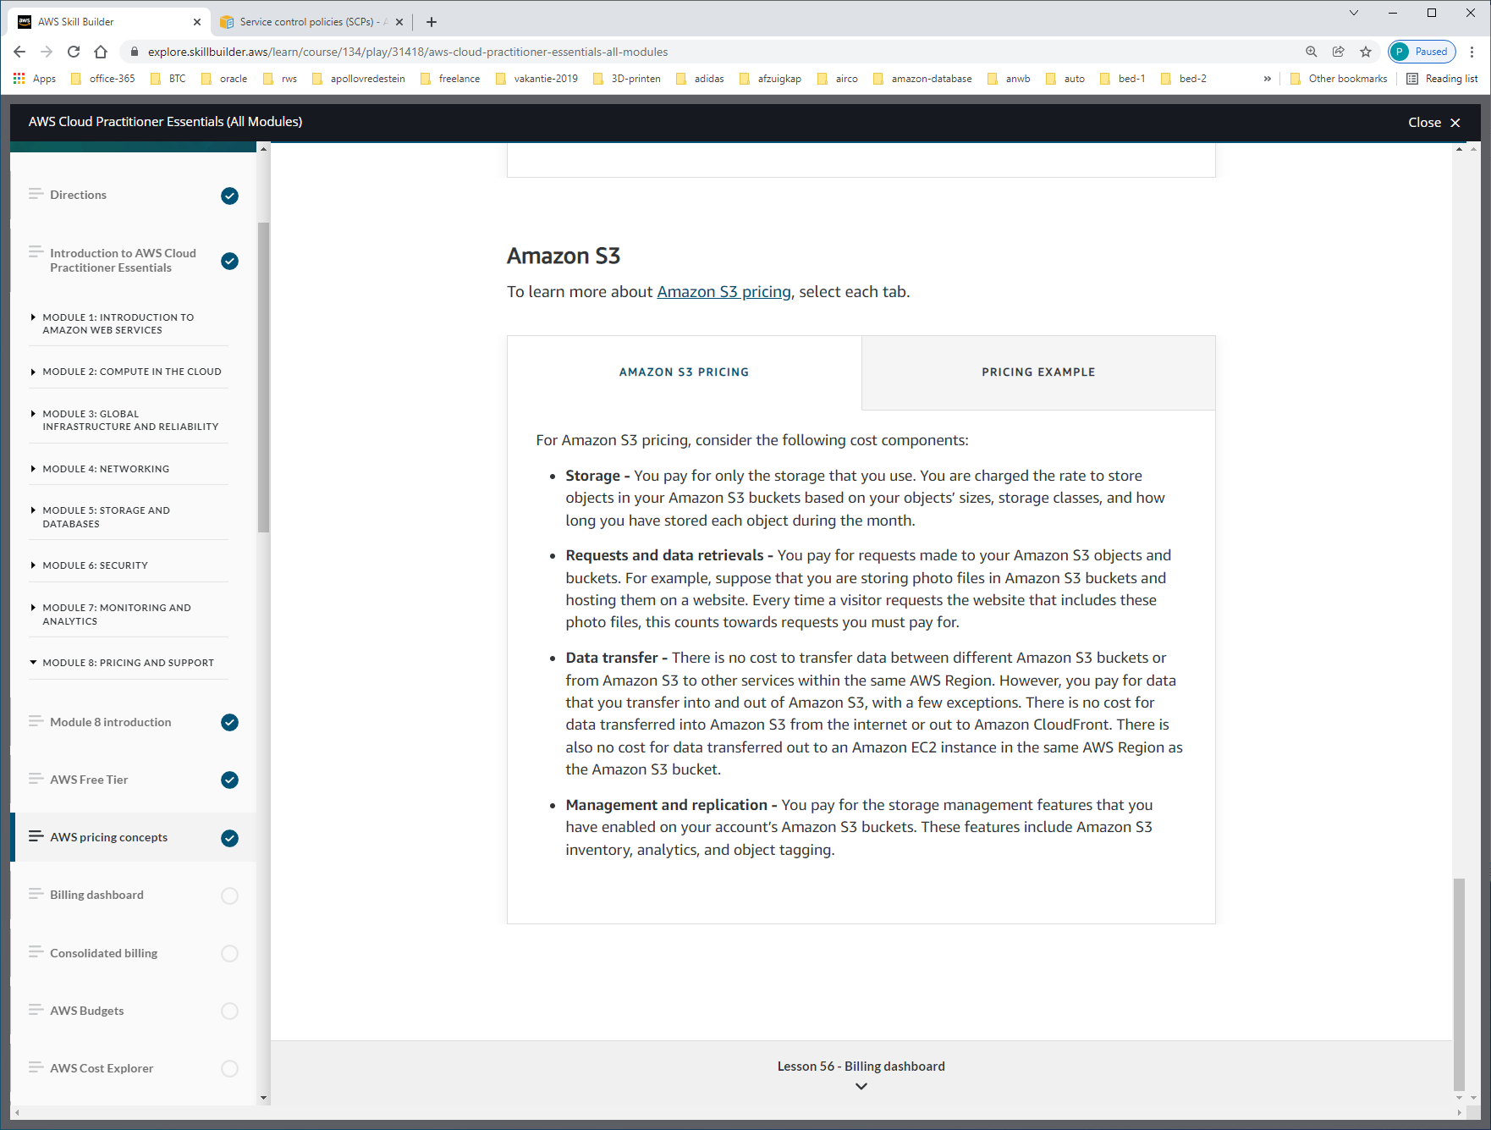

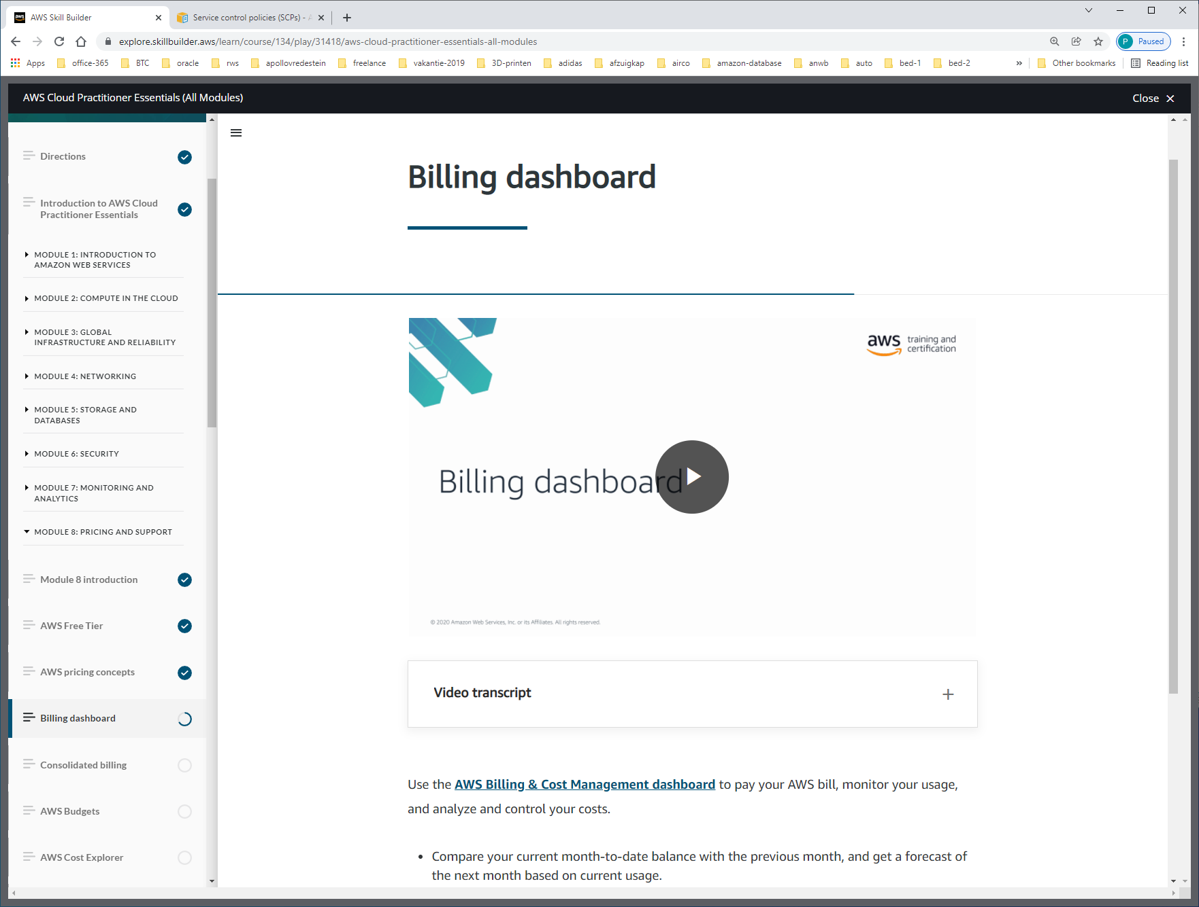

Use the [**AWS Billing & Cost Management dashboard**](https://docs.aws.amazon.com/awsaccountbilling/latest/aboutv2/billing-what-is.html) to pay your AWS bill, monitor your usage, and analyze and control your costs.

* Compare your current month-to-date balance with the previous month, and get a forecast of the next month based on current usage.
* View month-to-date spend by service.
* View Free Tier usage by service.
* Access Cost Explorer and create budgets.
* Purchase and manage Savings Plans.
* Publish [AWS Cost and Usage Reports](https://docs.aws.amazon.com/cur/latest/userguide/what-is-cur.html).

Vanuit management-console

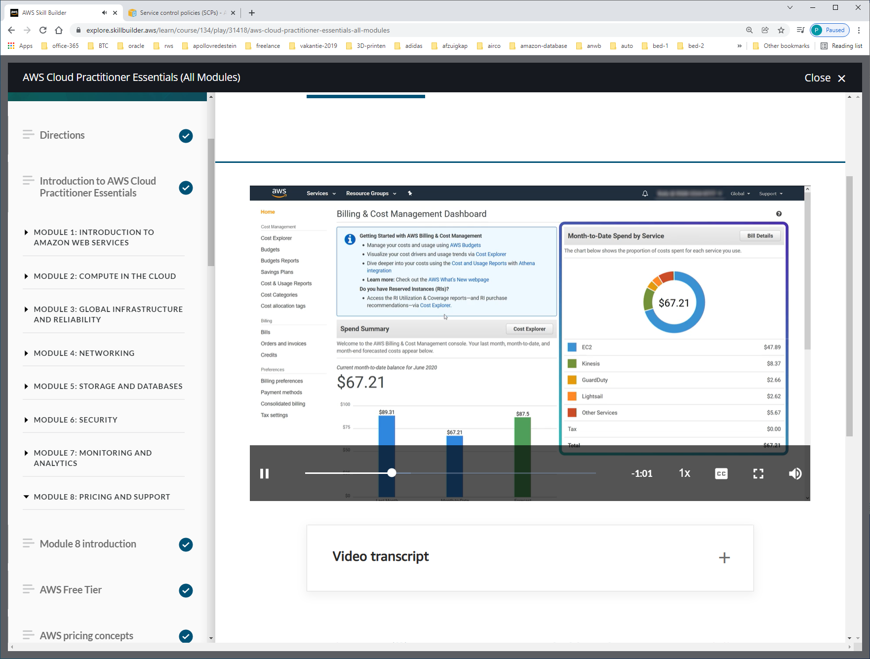

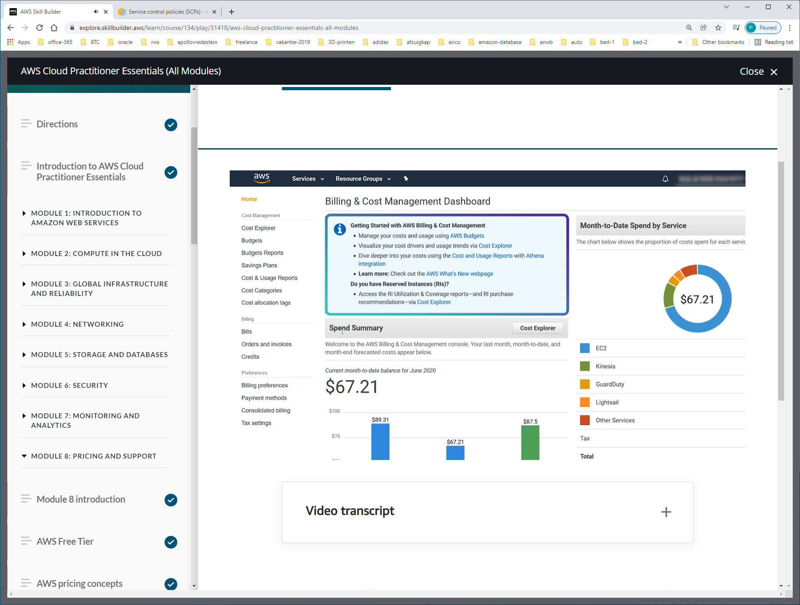

En je hebt toegang tot andere services. Bijv. BILLING.

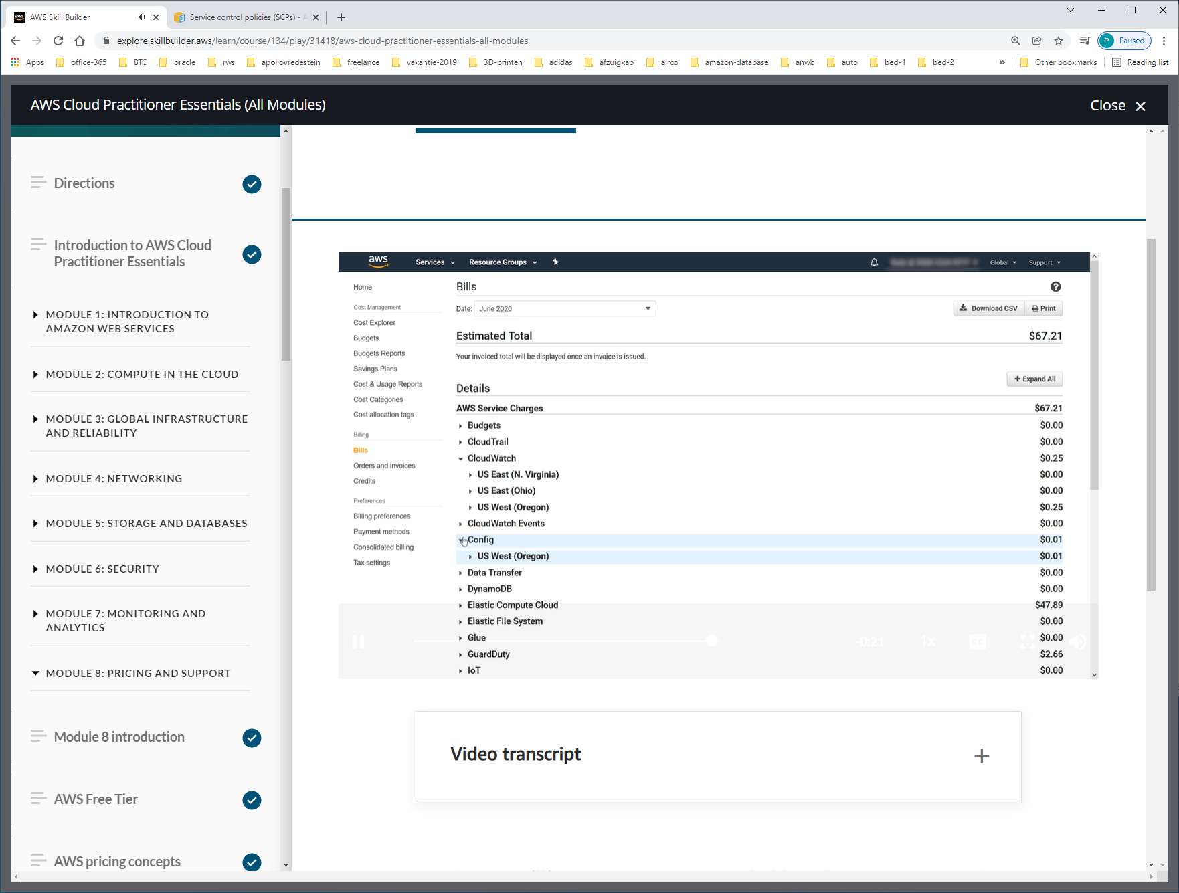

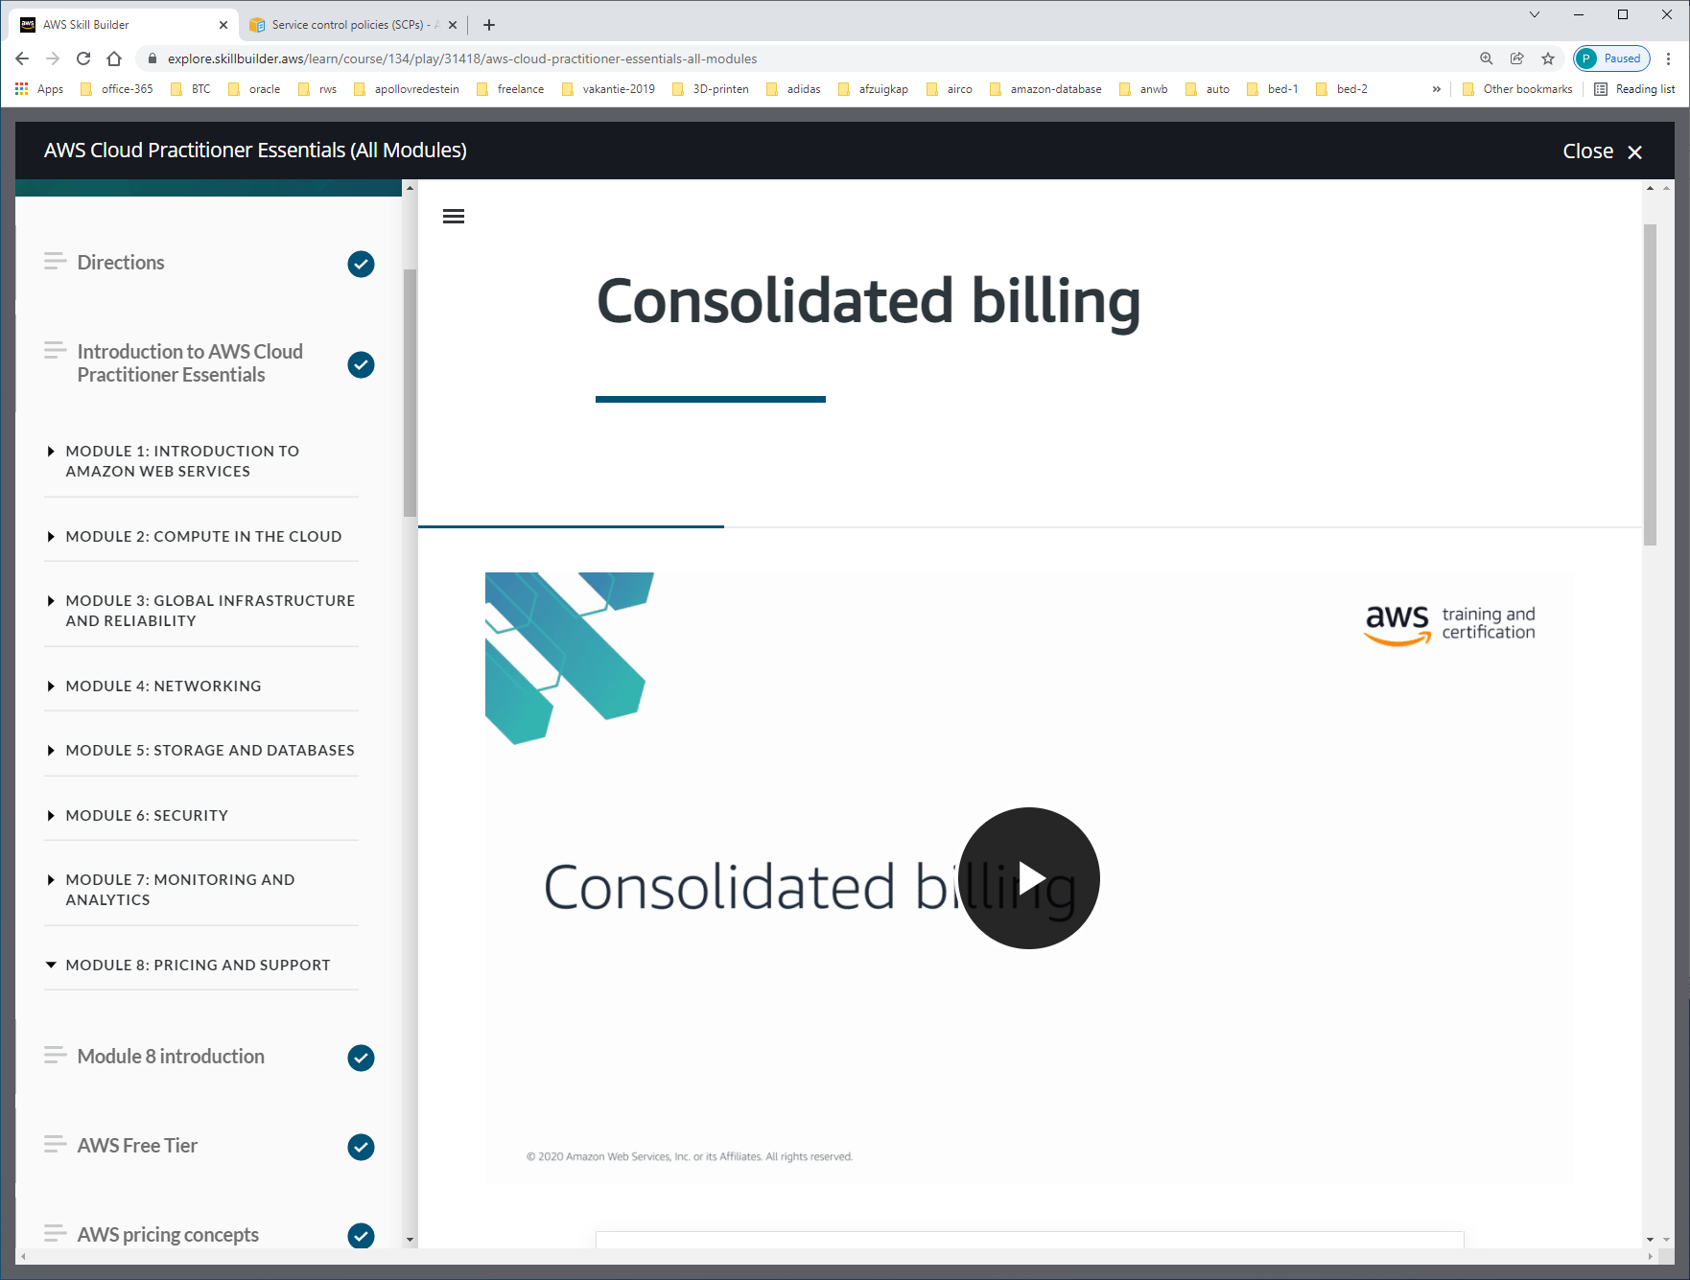

Meestal meerdere AWS-accounts binnen 1 organisatie. Voor ieder AWS-account 1 BILL.

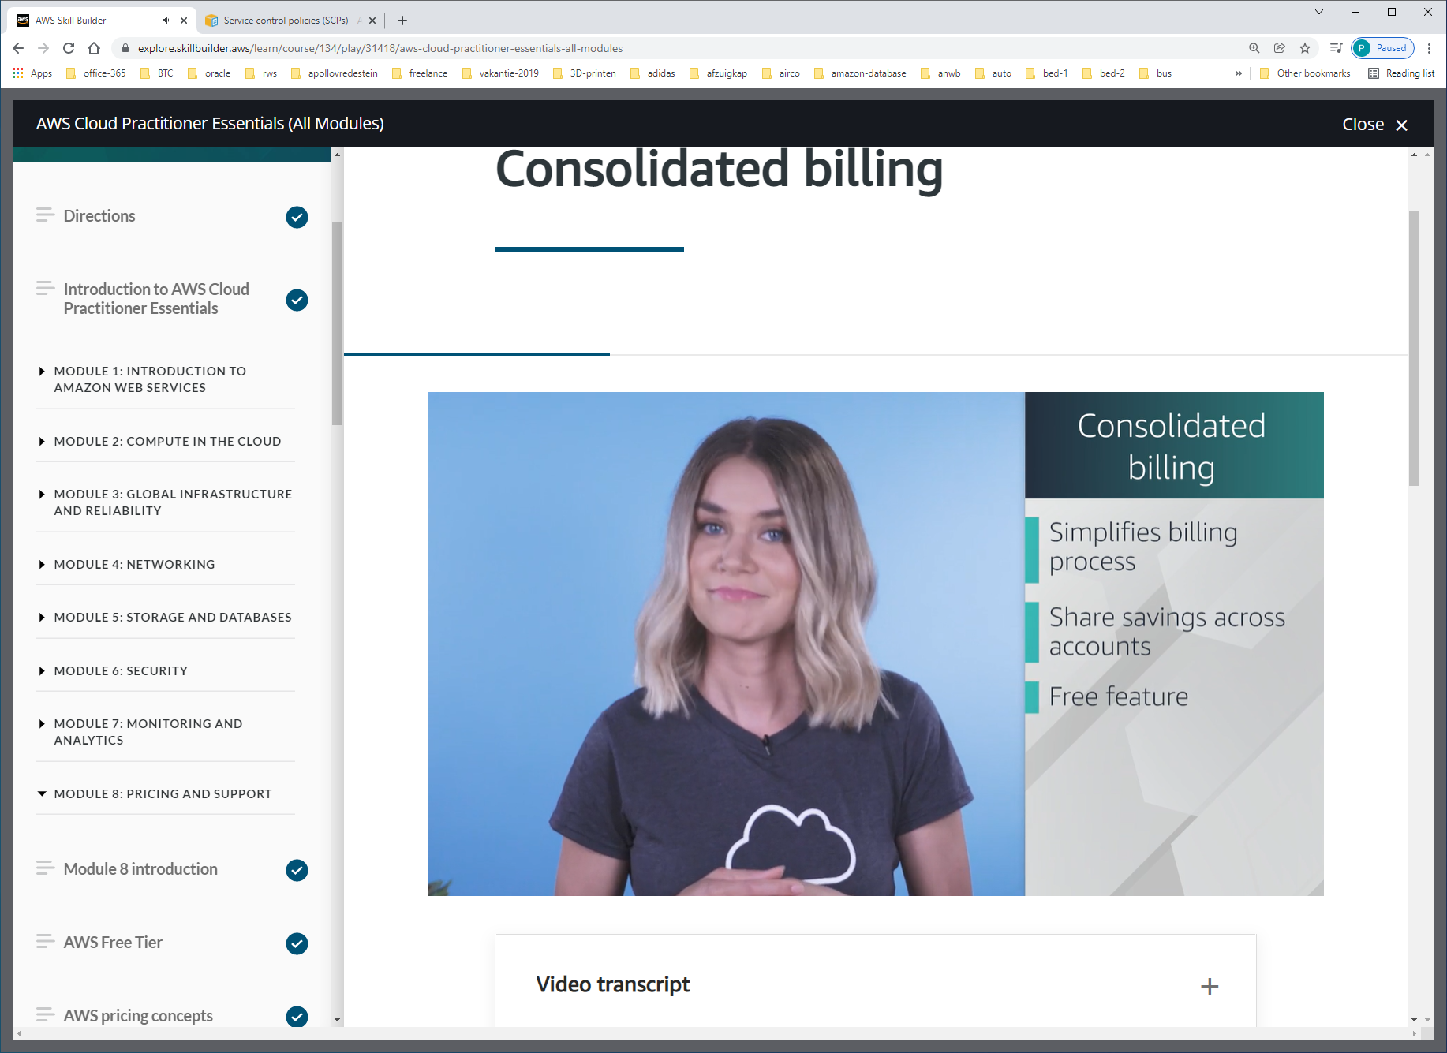

AWS Organizations also provides the option for [**consolidated billing**](https://docs.aws.amazon.com/awsaccountbilling/latest/aboutv2/consolidated-billing.html).

The consolidated billing feature of AWS Organizations enables you to receive a single bill for all AWS accounts in your organization. By consolidating, you can easily track the combined costs of all the linked accounts in your organization. The default maximum number of accounts allowed for an organization is 4, but you can contact AWS Support to increase your quota, if needed.

On your monthly bill, you can review itemized charges incurred by each account. This enables you to have greater transparency into your organization’s accounts while still maintaining the convenience of receiving a single monthly bill.

Another benefit of consolidated billing is the ability to share bulk discount pricing, Savings Plans, and Reserved Instances across the accounts in your organization. For instance, one account might not have enough monthly usage to qualify for discount pricing. However, when multiple accounts are combined, their aggregated usage may result in a benefit that applies across all accounts in the organization.

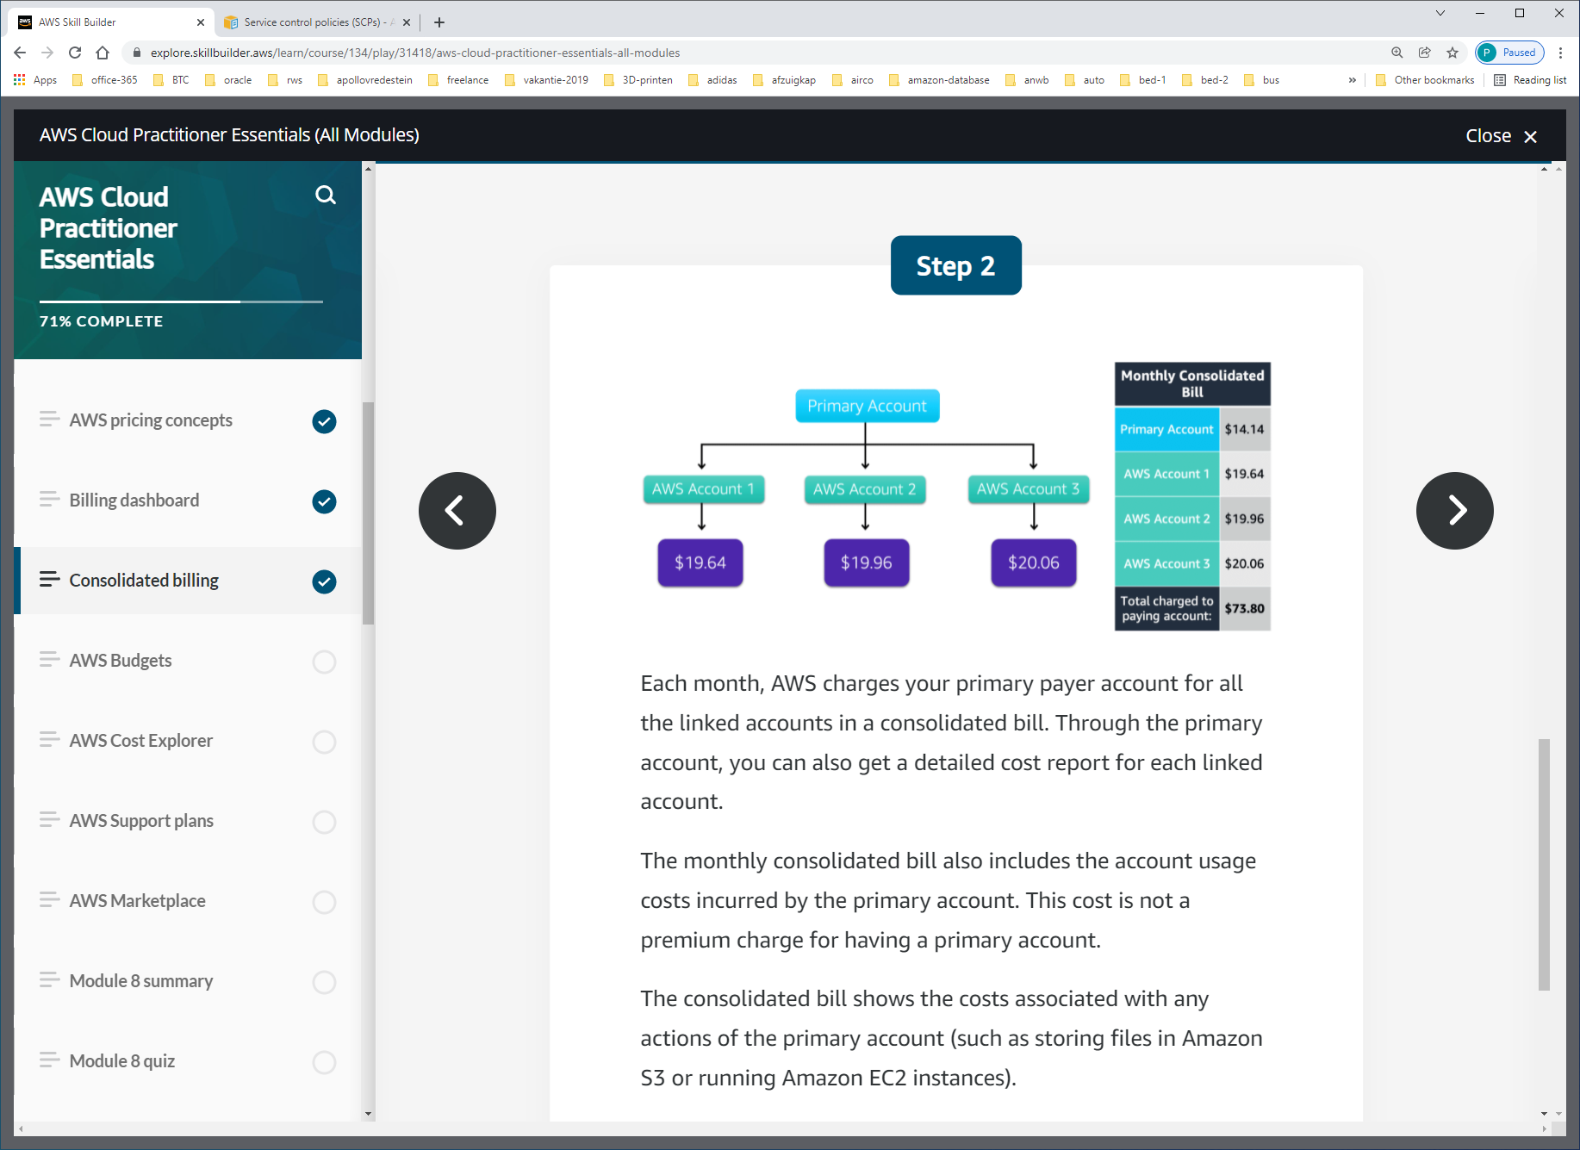

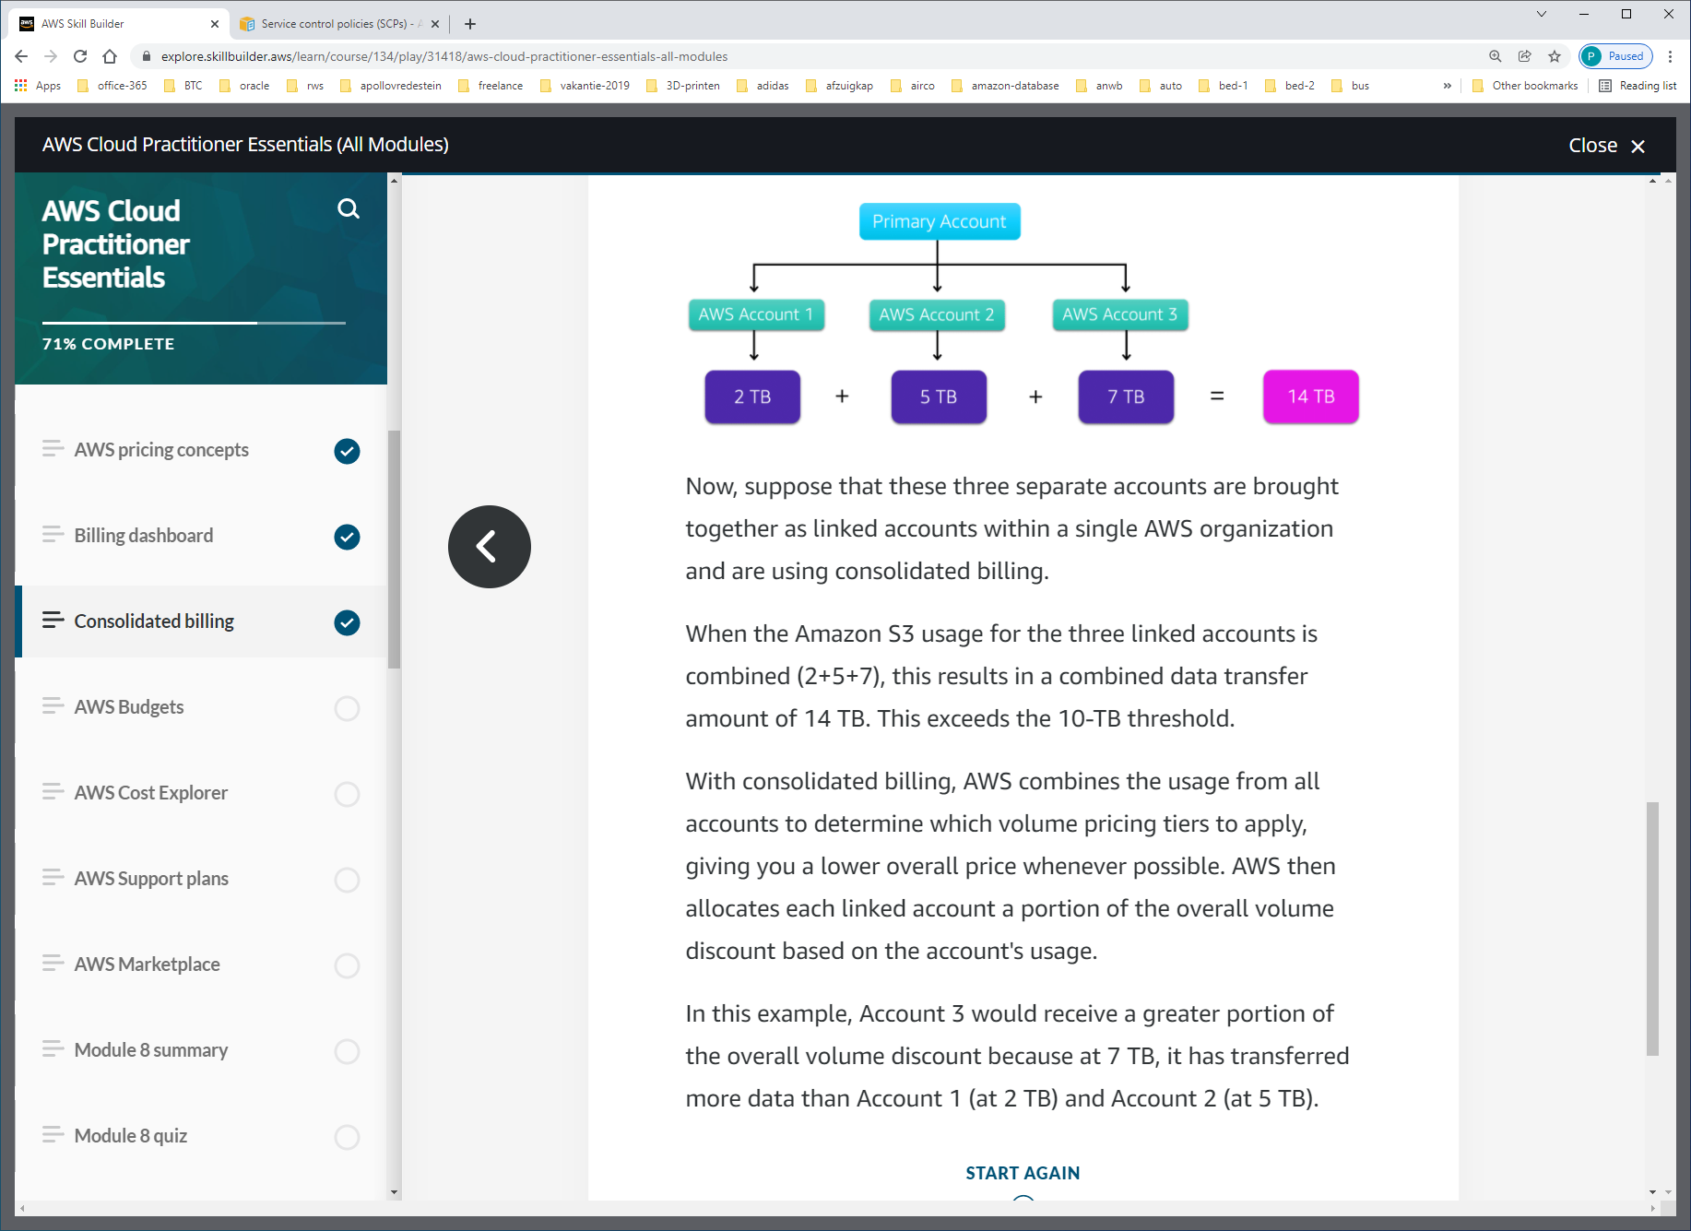

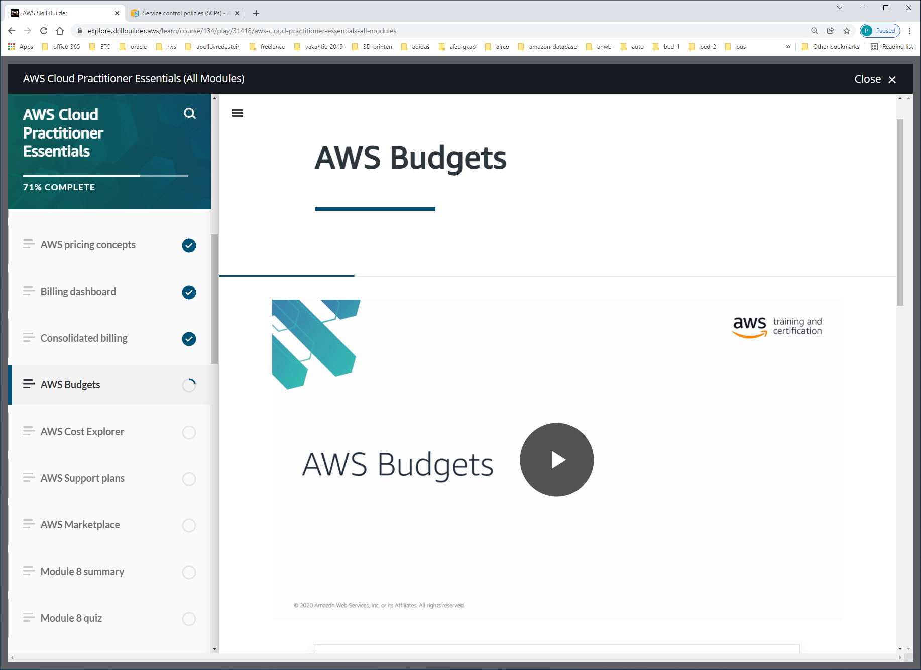

In [**AWS Budgets**](https://aws.amazon.com/aws-cost-management/aws-budgets), you can create budgets to plan your service usage, service costs, and instance reservations.

The information in AWS Budgets updates three times a day. This helps you to accurately determine how close your usage is to your budgeted amounts or to the AWS Free Tier limits.

In AWS Budgets, you can also set custom alerts when your usage exceeds (or is forecasted to exceed) the budgeted amount.

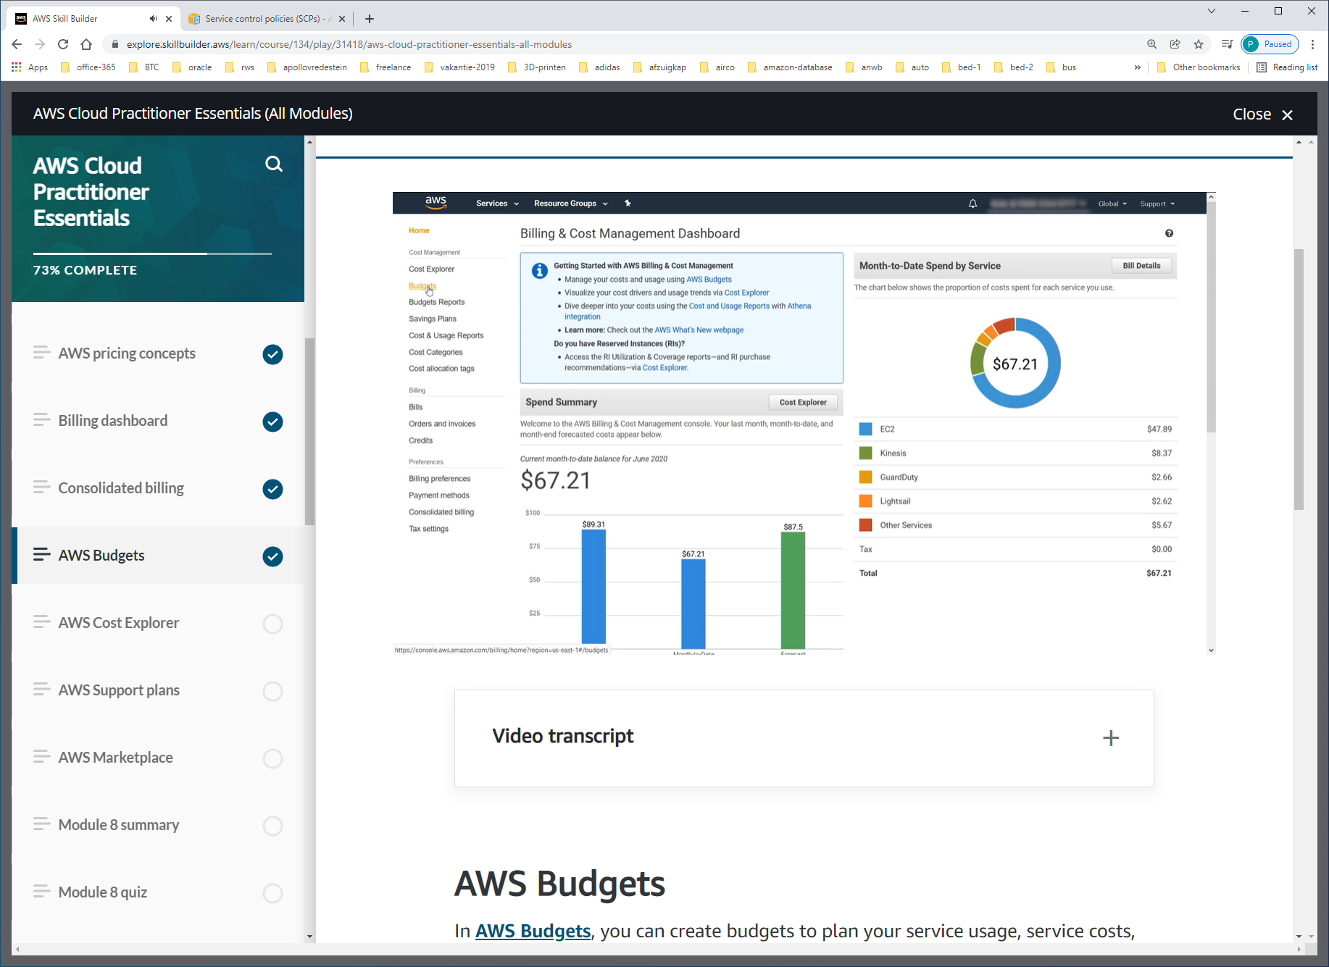

En rechtsboven create budget

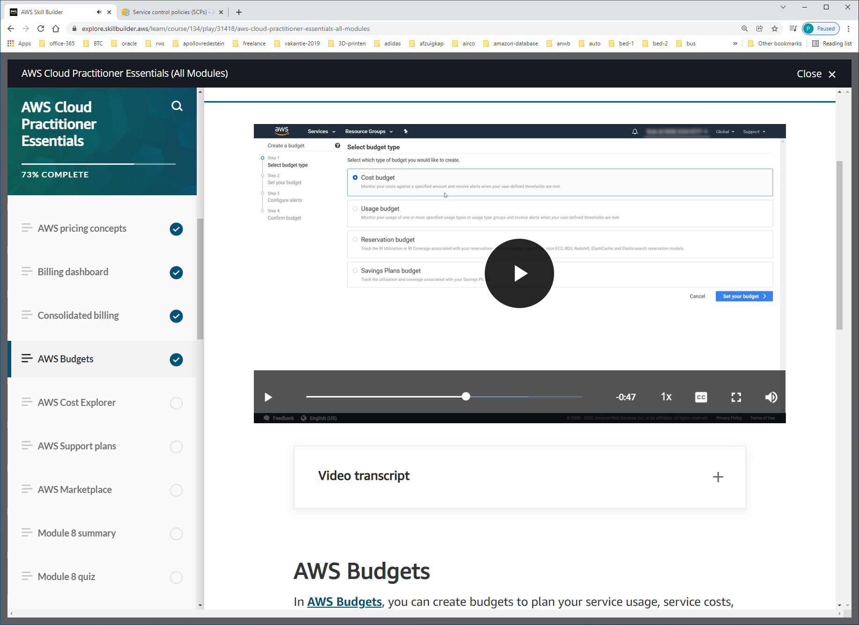

Choose budget

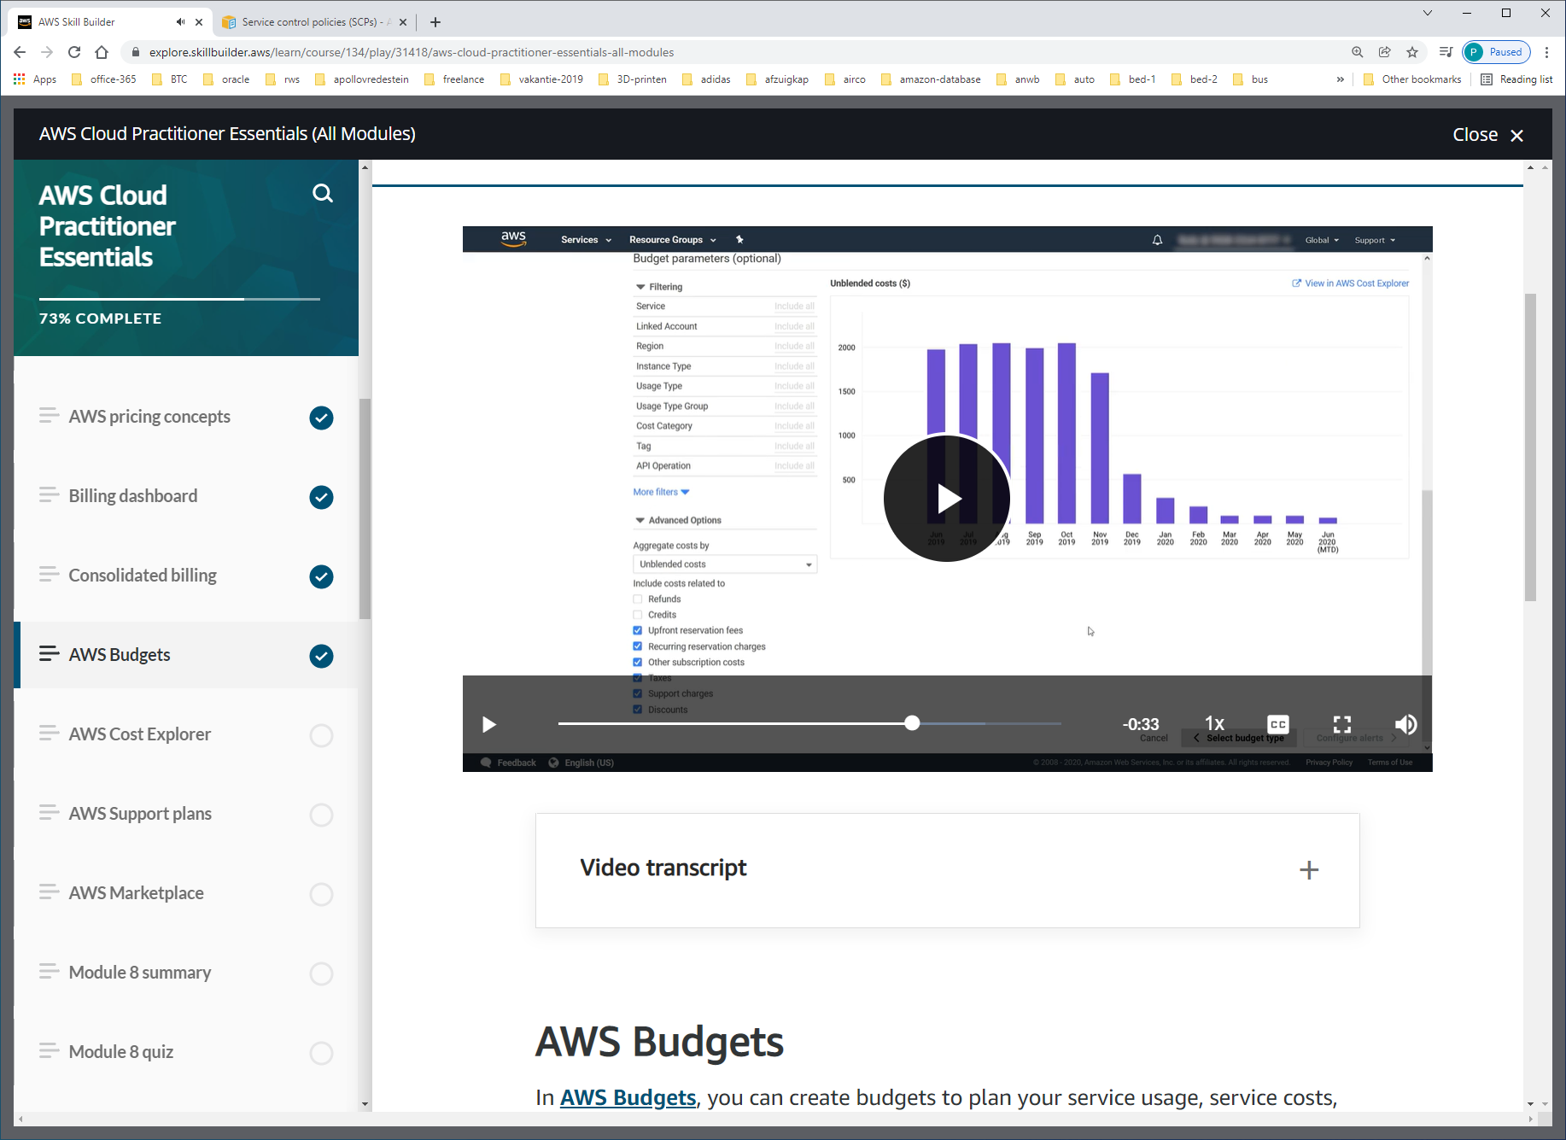

Configureer budget

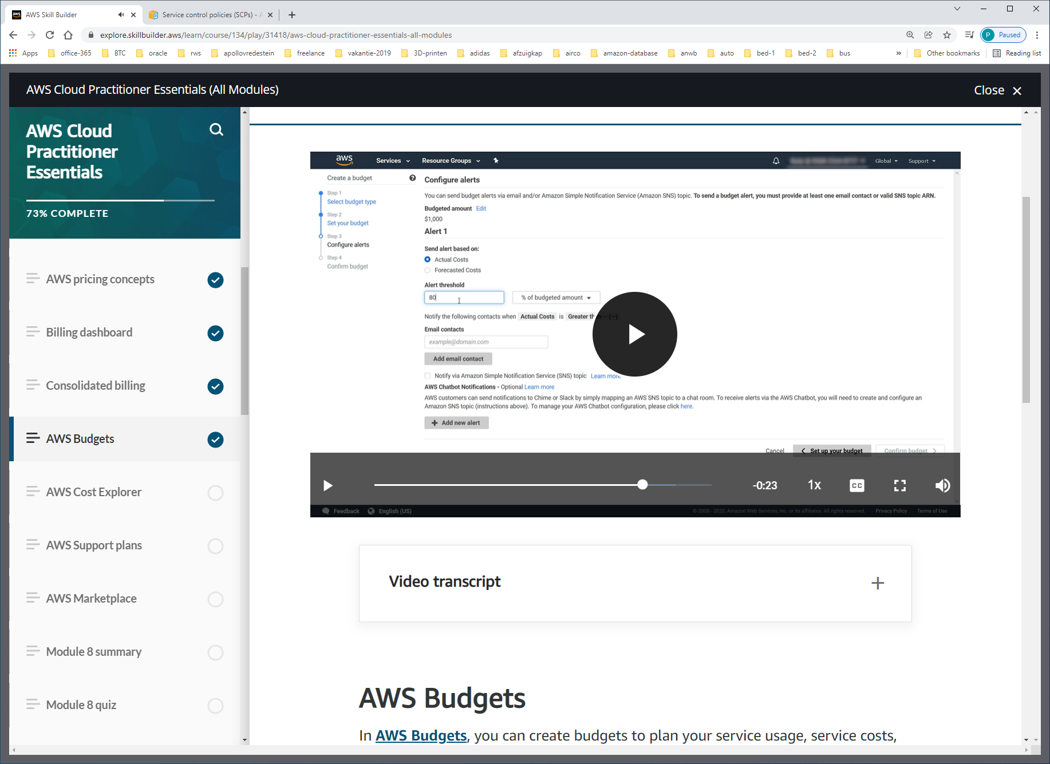

Stel alerts in

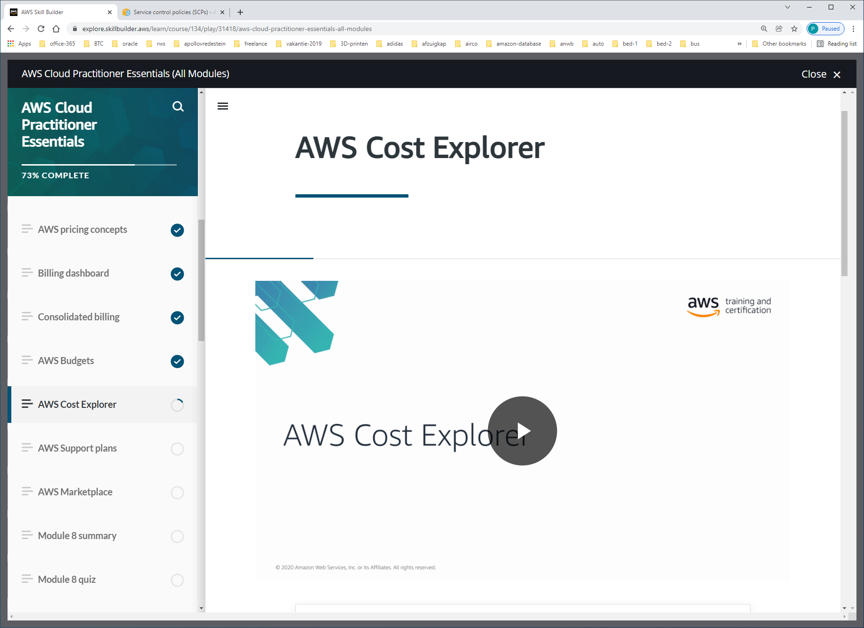

[**AWS Cost Explorer**](https://aws.amazon.com/aws-cost-management/aws-cost-explorer/) is a tool that enables you to visualize, understand, and manage your AWS costs and usage over time.

AWS Cost Explorer includes a default report of the costs and usage for your top five cost-accruing AWS services. You can apply custom filters and groups to analyze your data. For example, you can view resource usage at the hourly level.

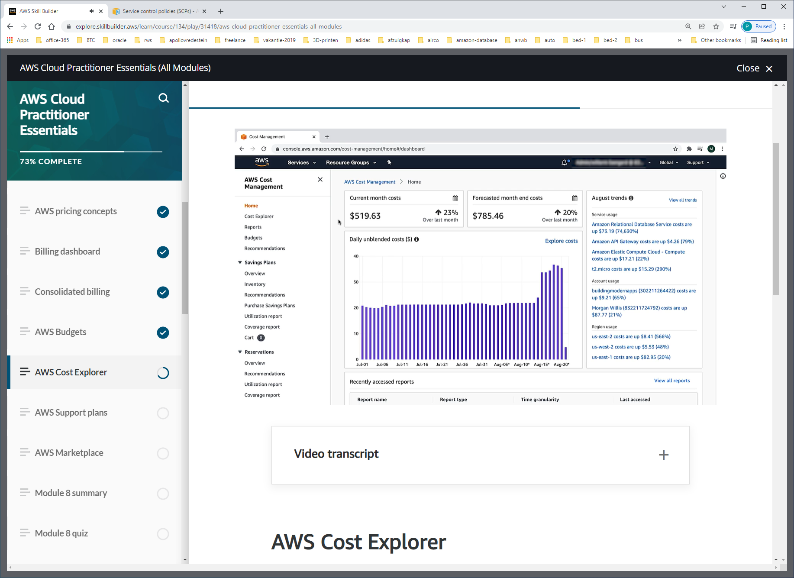

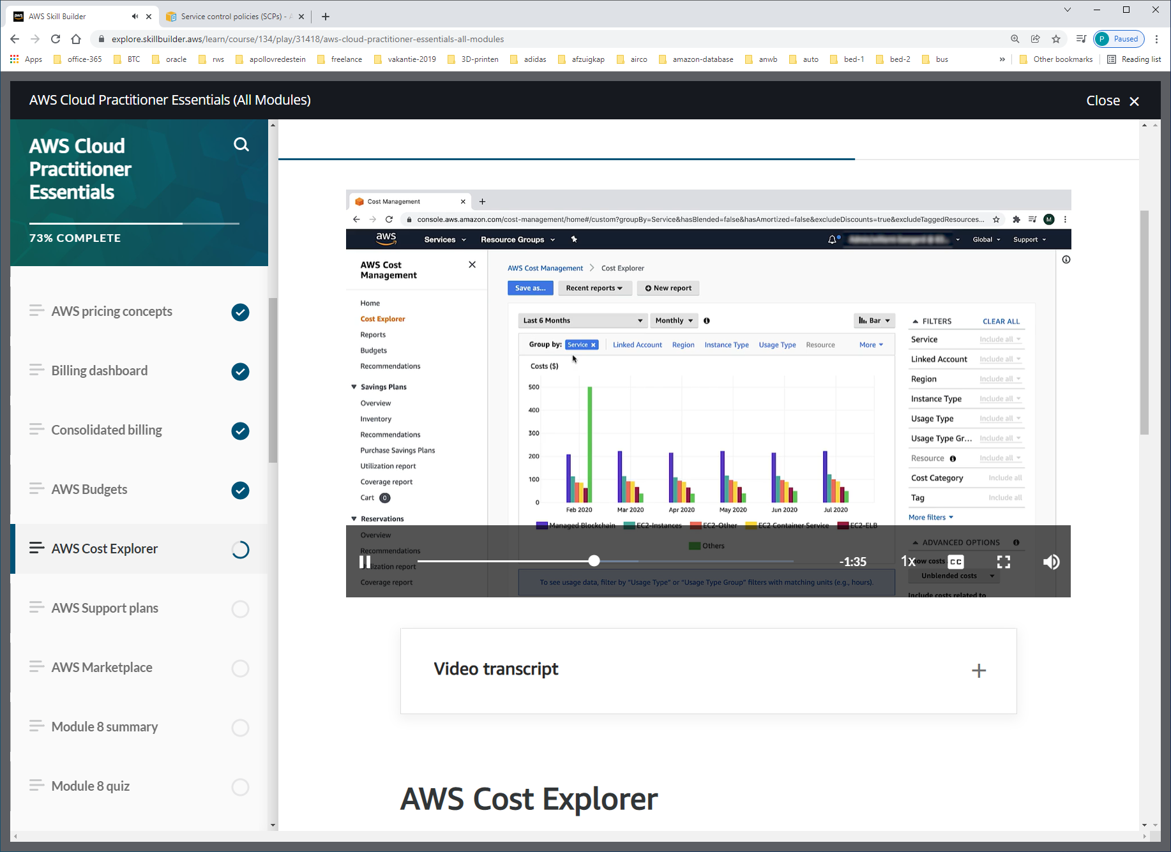

Ook group by tag mogelijk. Bijv. database of EC2-instance.

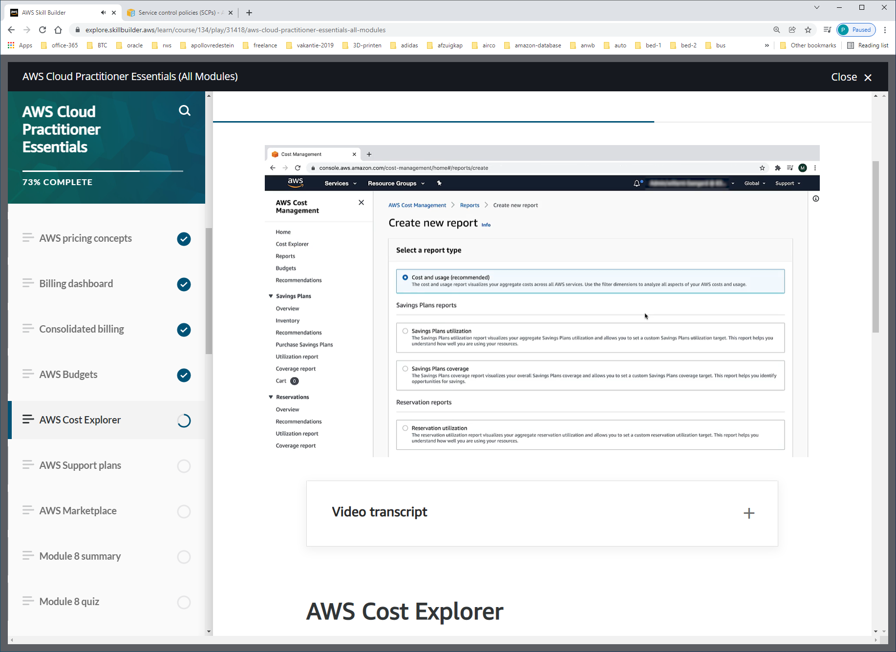

Je kunt over willekeurige periode ook een report maken.

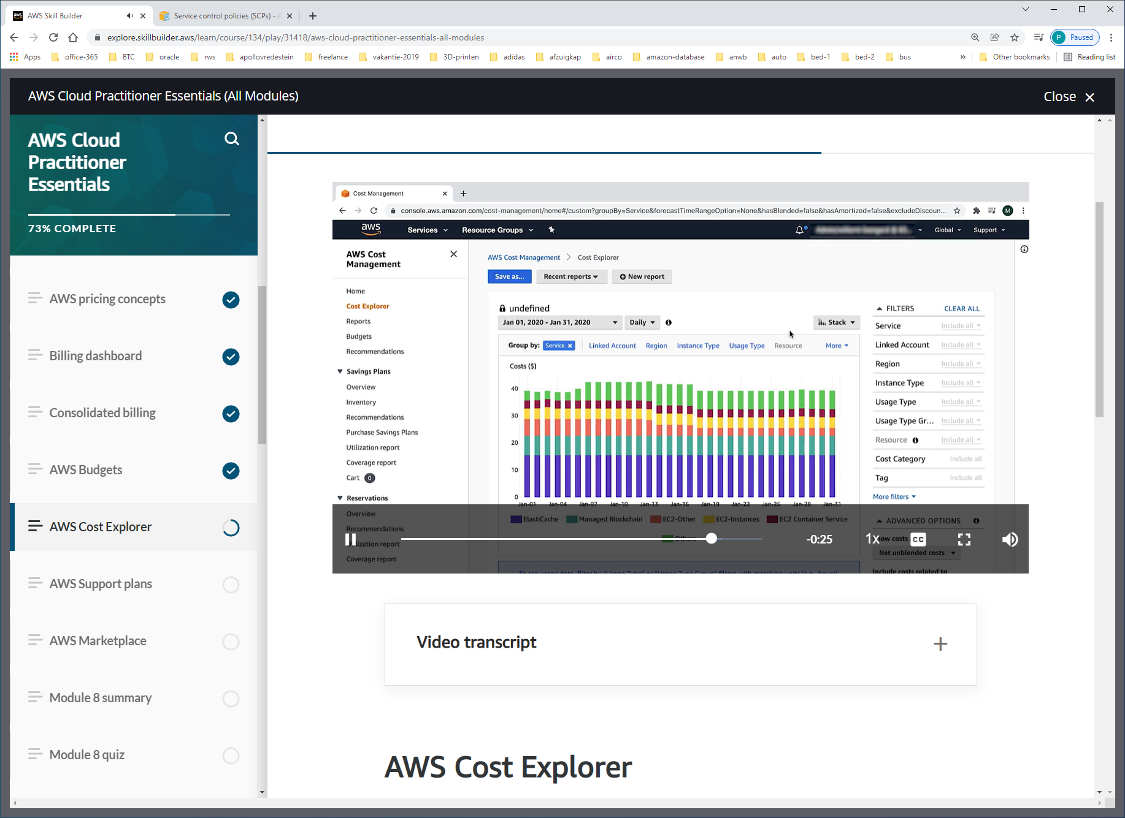

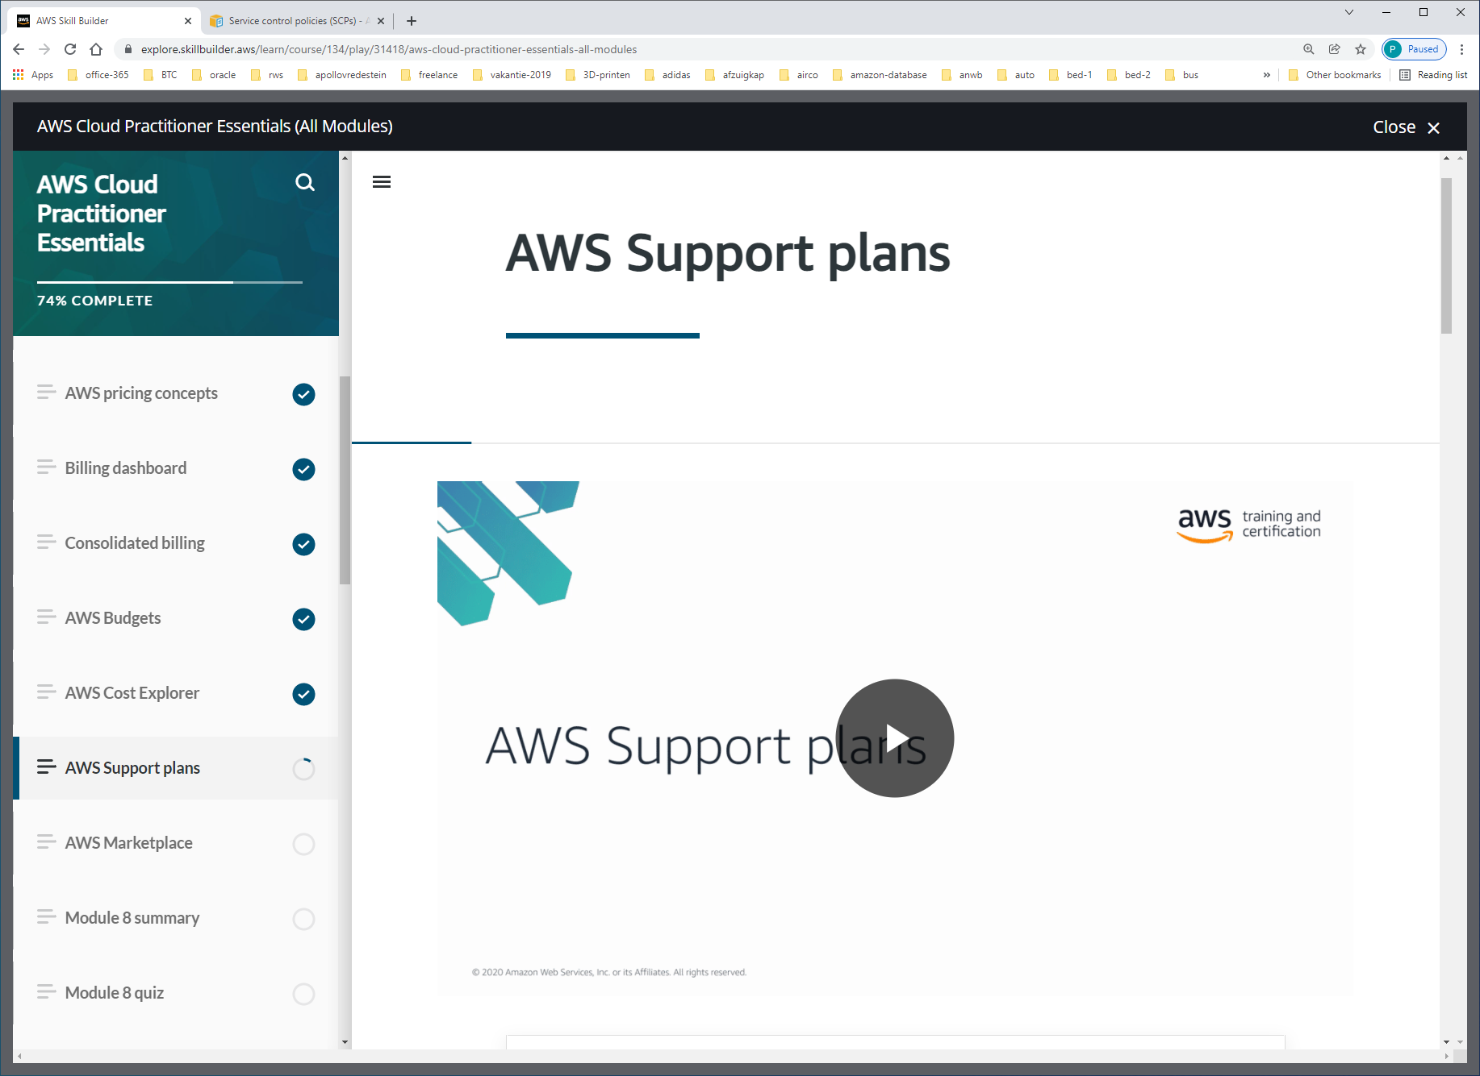

AWS offers four different [**Support plans**](https://aws.amazon.com/premiumsupport/plans/) to help you troubleshoot issues, lower costs, and efficiently use AWS services.

You can choose from the following Support plans to meet your company’s needs:

* Basic
* Developer
* Business
* Enterprise

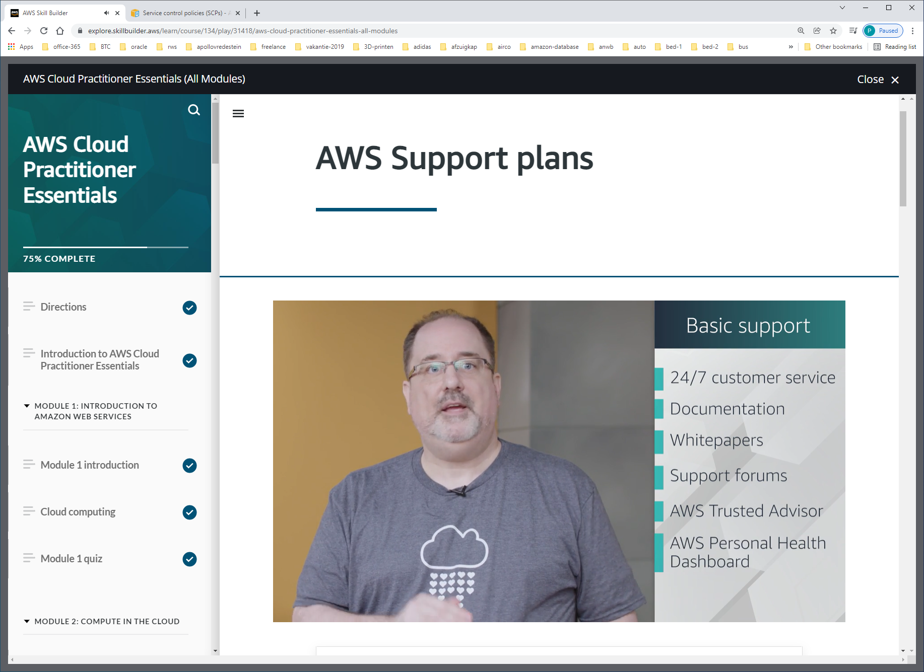

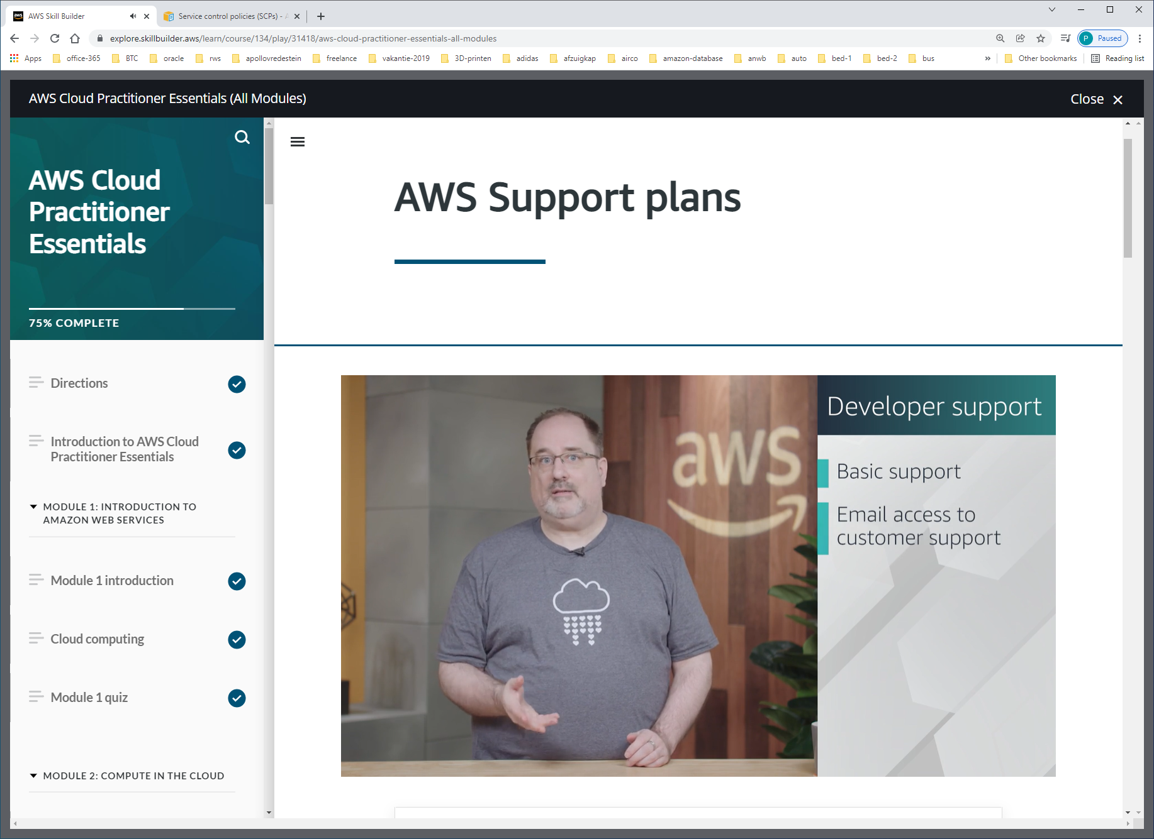

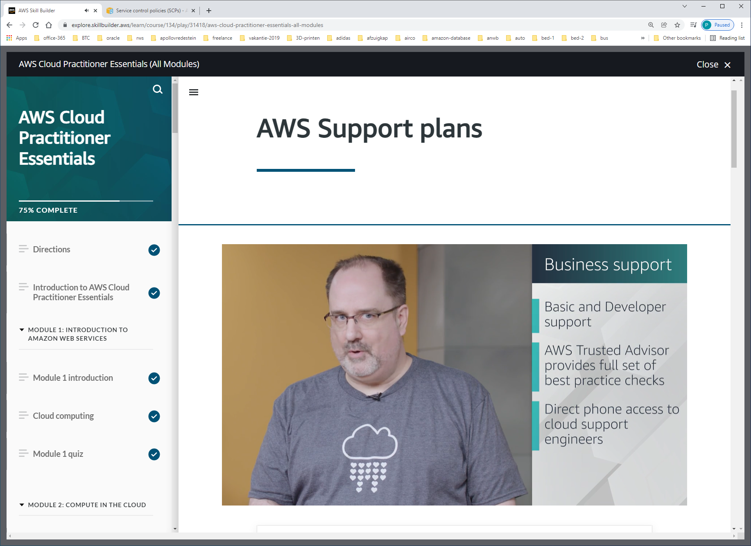

Binnen 4 uur reageren, of binnen 1 uur indien service unavailable.

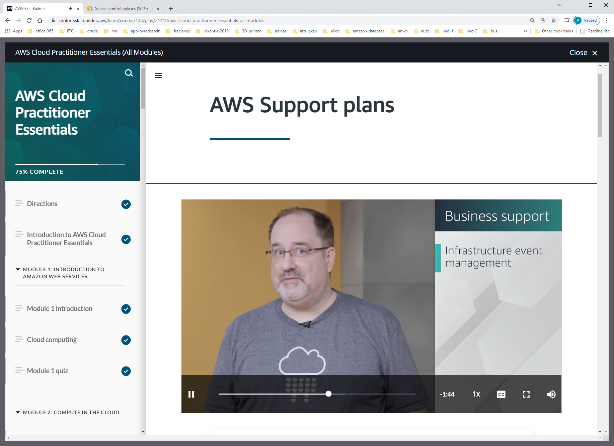

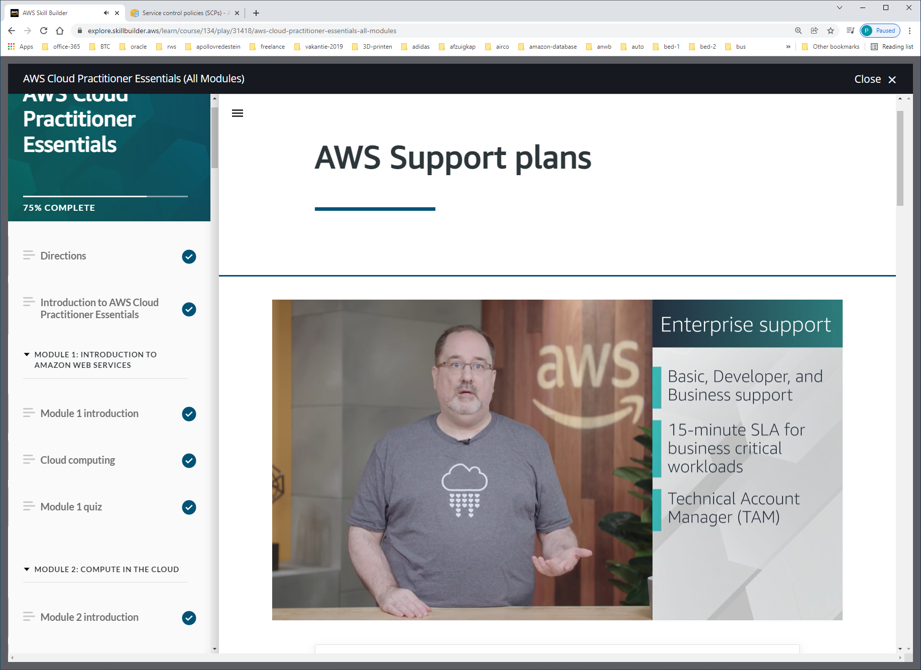

TAM = technical accountmanager, review well-architect framework

The Enterprise Support plan includes access to a **Technical Account Manager (TAM)**.

If your company has an Enterprise Support plan, the TAM is your primary point of contact at AWS. They provide guidance, architectural reviews, and ongoing communication with your company as you plan, deploy, and optimize your applications.

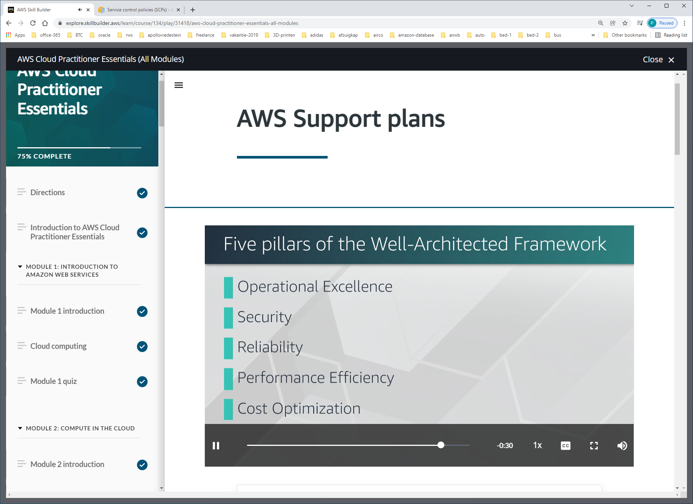

WELL-ARCHITECTED-FRAMEWORK:  
-operational excellence  
-security  
-reliability  
-performance efficiency  
-cost-optimization

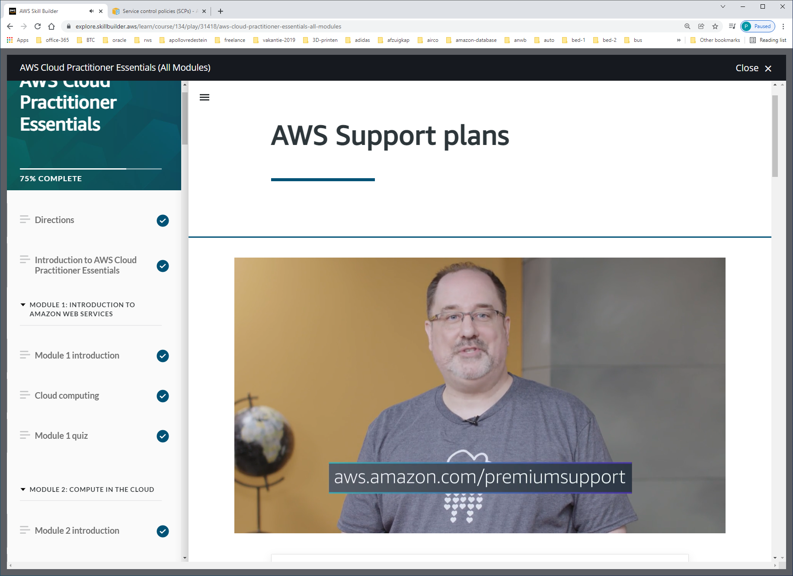

**Basic Support** is free for all AWS customers. It includes access to whitepapers, documentation, and support communities. With Basic Support, you can also contact AWS for billing questions and service limit increases.

With Basic Support, you have access to a limited selection of AWS Trusted Advisor checks. Additionally, you can use the **AWS Personal Health Dashboard**, a tool that provides alerts and remediation guidance when AWS is experiencing events that may affect you.

**Developer Support**

Customers in the **Developer Support** plan have access to features such as:

* Best practice guidance
* Client-side diagnostic tools
* Building-block architecture support, which consists of guidance for how to use AWS offerings, features, and services together

For example, suppose that your company is exploring AWS services. You’ve heard about a few different AWS services. However, you’re unsure of how to potentially use them together to build applications that can address your company’s needs. In this scenario, the building-block architecture support that is included with the Developer Support plan could help you to identify opportunities for combining specific services and features.

**Business Support**

Customers with a **Business Support** plan have access to additional features, including:

* Use-case guidance to identify AWS offerings, features, and services that can best support your specific needs
* All AWS Trusted Advisor checks
* Limited support for third-party software, such as common operating systems and application stack components

Suppose that your company has the Business Support plan and wants to install a common third-party operating system onto your Amazon EC2 instances. You could contact AWS Support for assistance with installing, configuring, and troubleshooting the operating system. For advanced topics such as optimizing performance, using custom scripts, or resolving security issues, you may need to contact the third-party software provider directly.

**Enterprise Support**

In addition to all the features included in the Basic, Developer, and Business Support plans, customers with an **Enterprise Support** plan have access to features such as:

* Application architecture guidance, which is a consultative relationship to support your company’s specific use cases and applications
* Infrastructure event management: A short-term engagement with AWS Support that helps your company gain a better understanding of your use cases. This also provides your company with architectural and scaling guidance.
* A Technical Account Manager

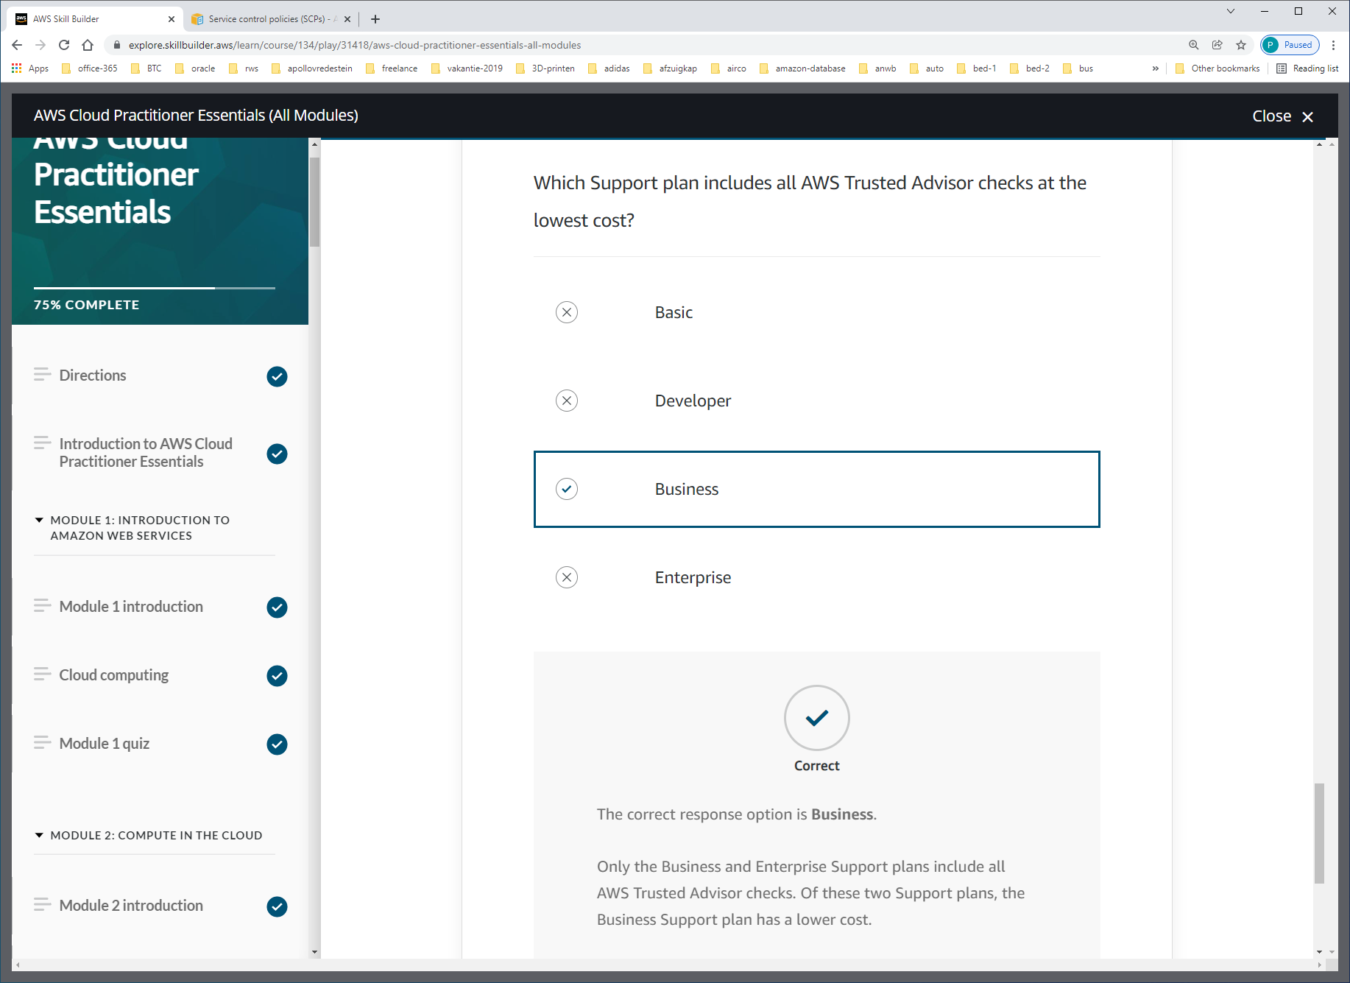

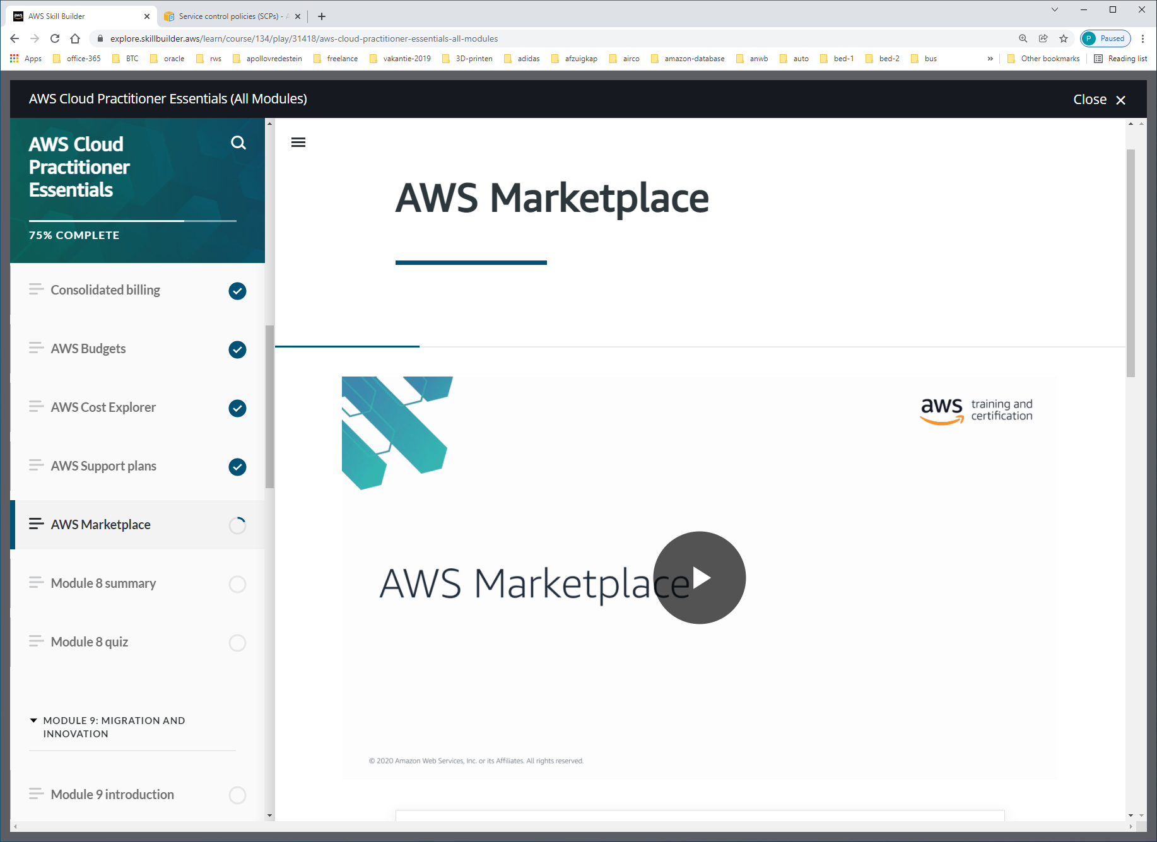

[**AWS Marketplace**](https://aws.amazon.com/marketplace) is a digital catalog that includes thousands of software listings from independent software vendors. You can use AWS Marketplace to find, test, and buy software that runs on AWS.

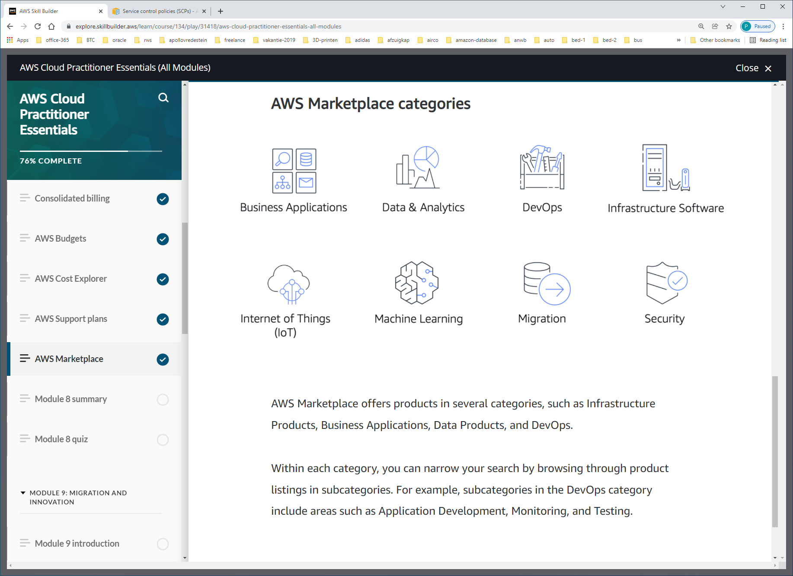

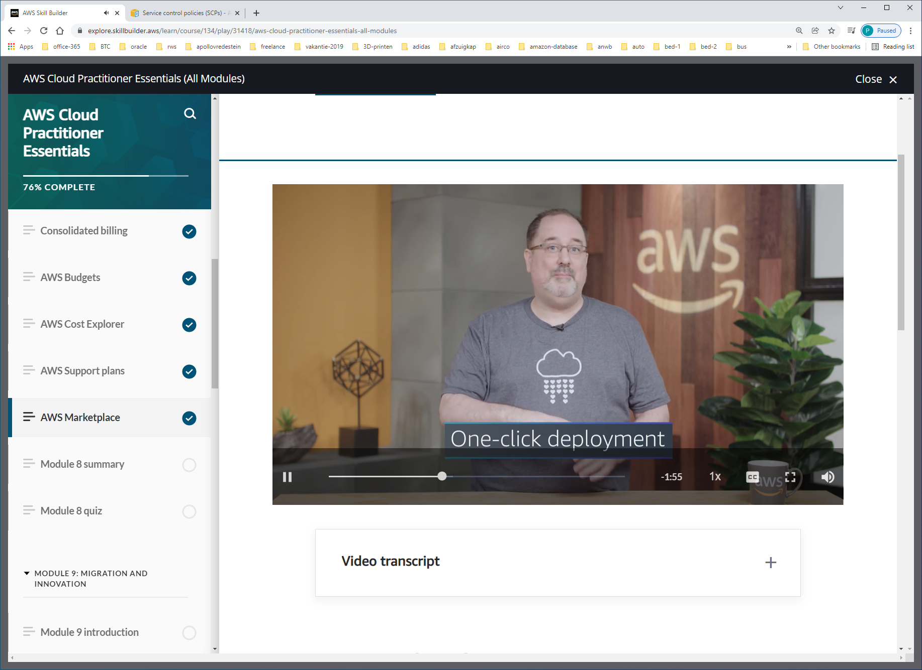

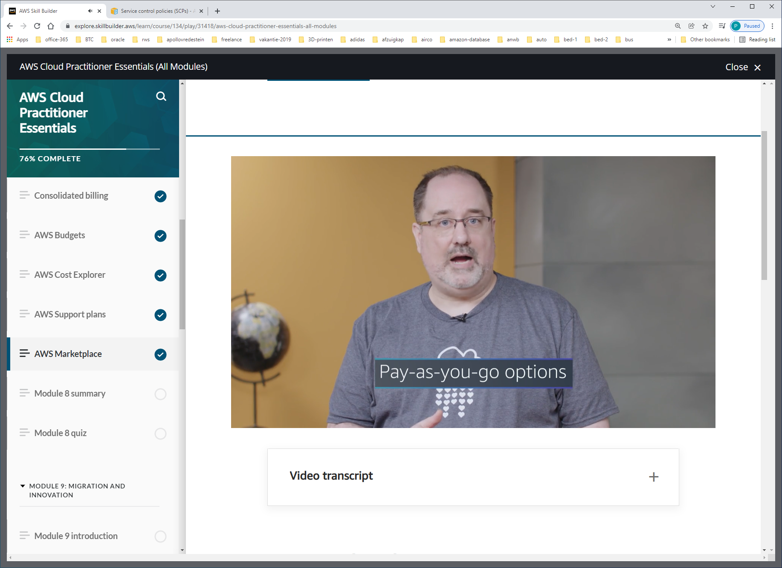

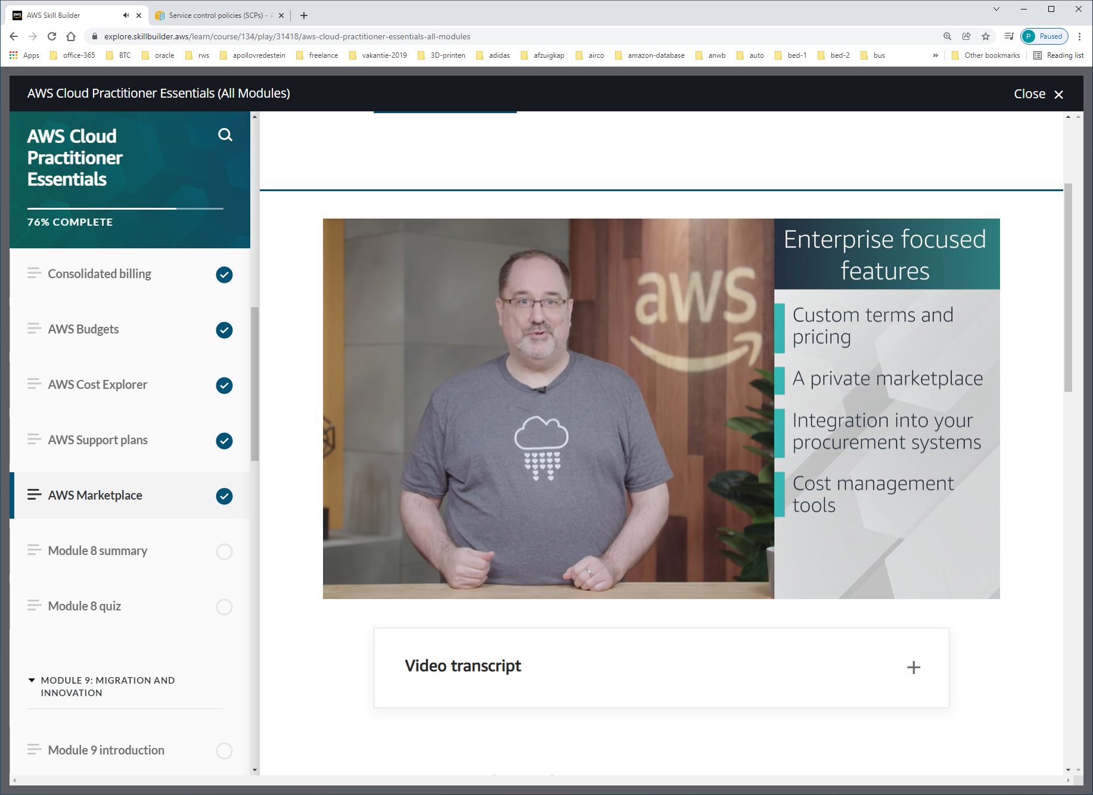

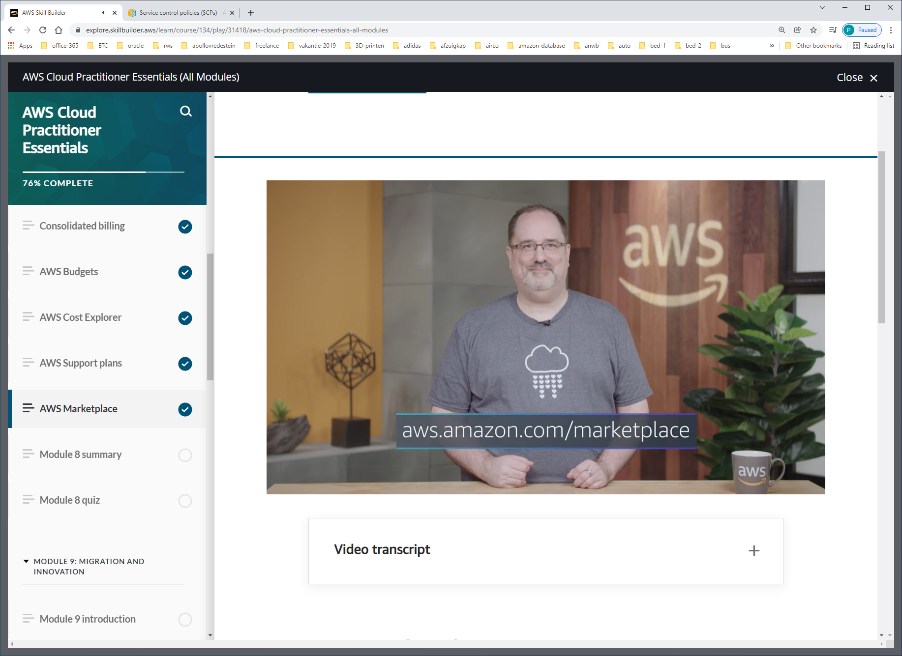

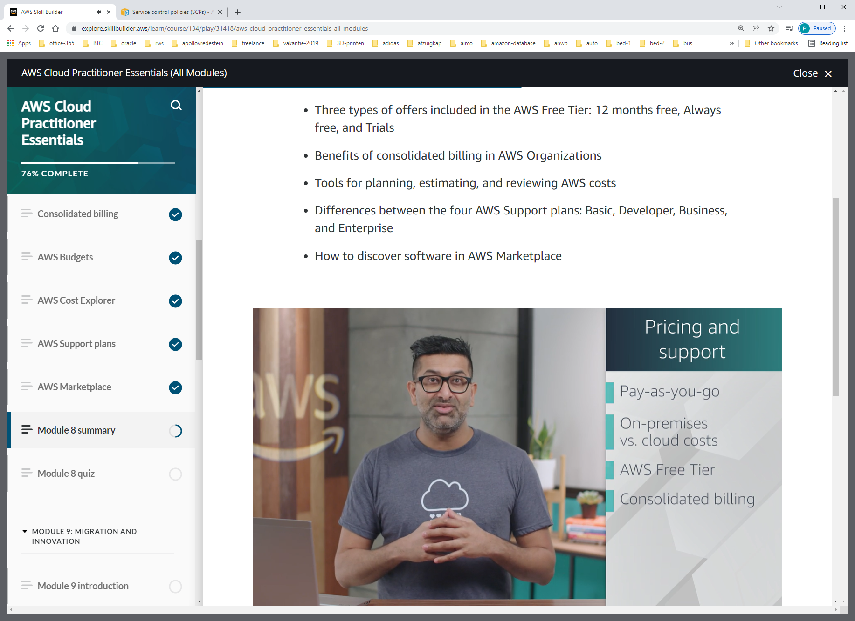

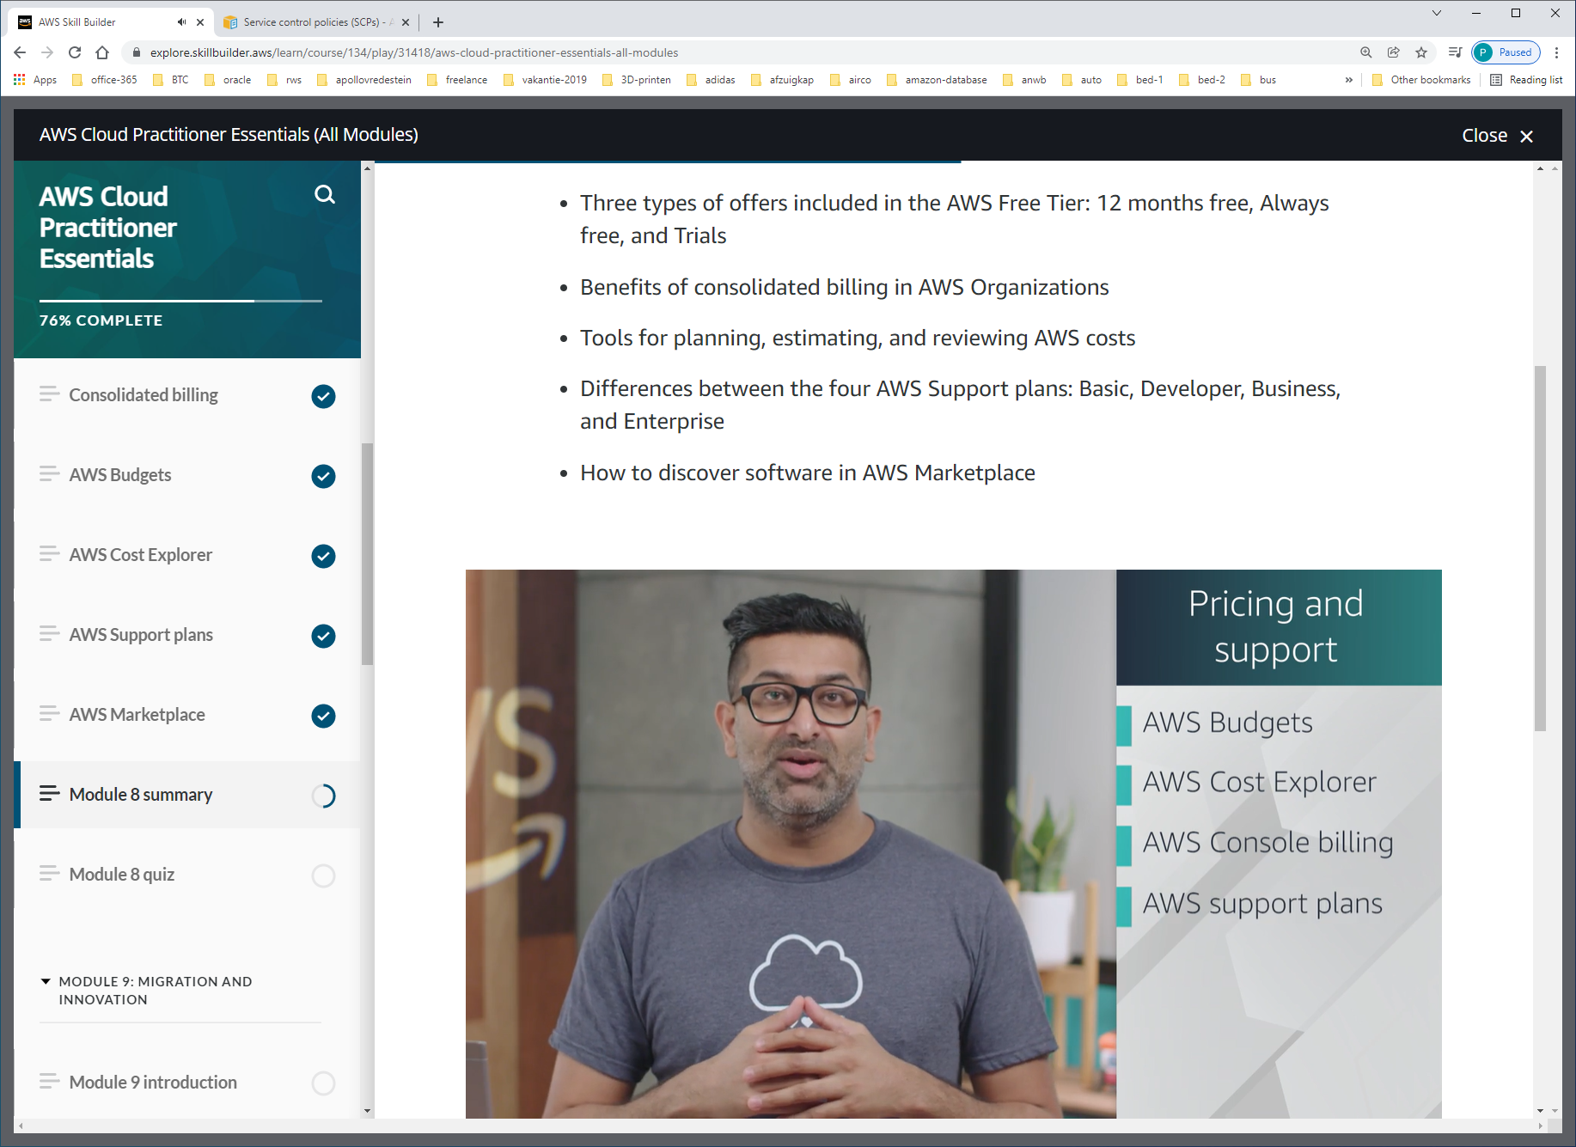

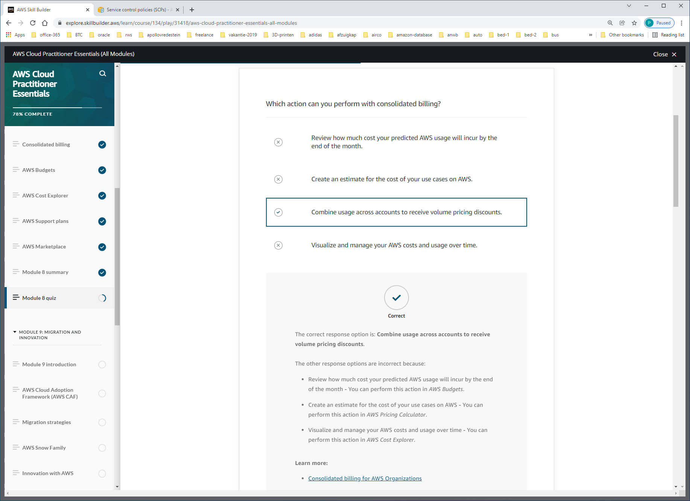

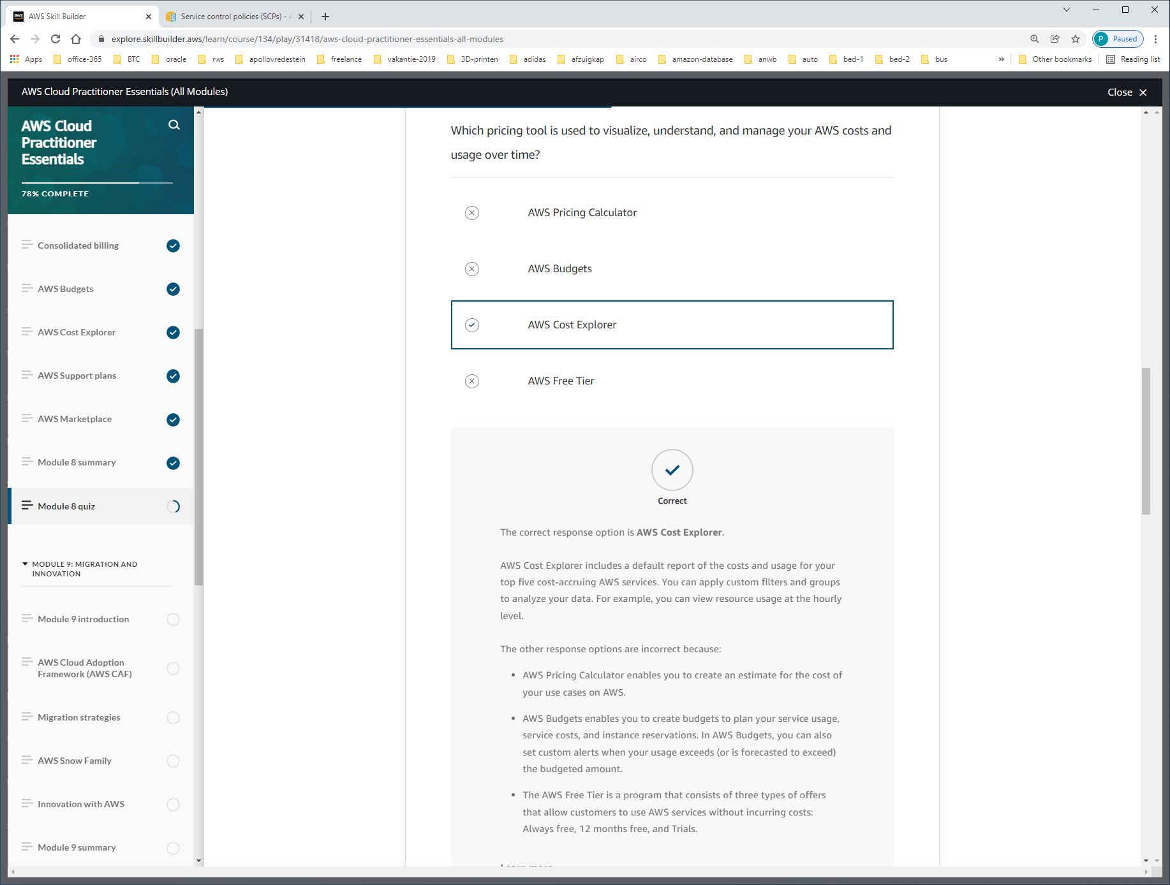

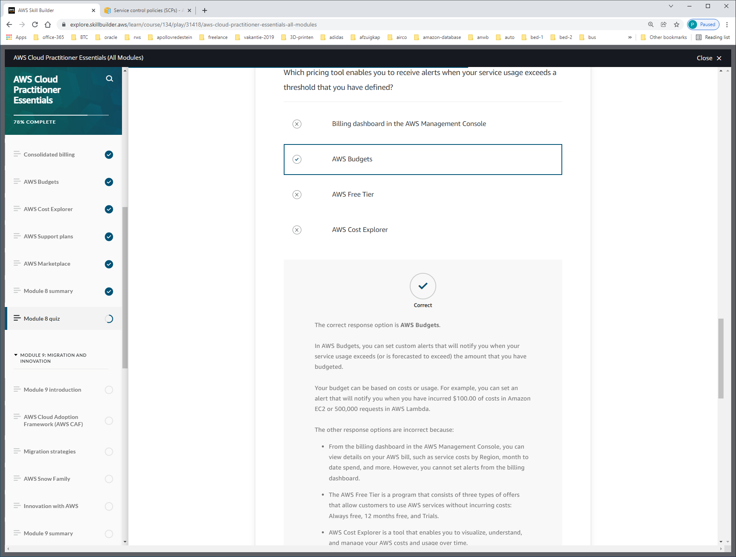

Your budget can be based on costs or usage.

